**fakeroot make -j$(nproc)**

**sudo make modules_install**

**sudo make install**

**sudo update-grub**

**sudo reboot**

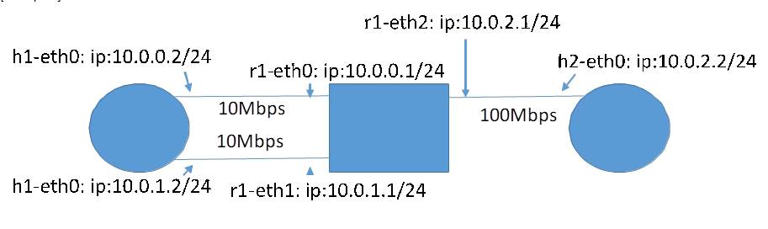



**Experiment 1**

MPTCP =0

Bandwidth=100mbps

h1-eth0 mtu 9000

h1-eth1 mtu 576

r1-eth0 mtu 9000

r1-eth1 mtu 576

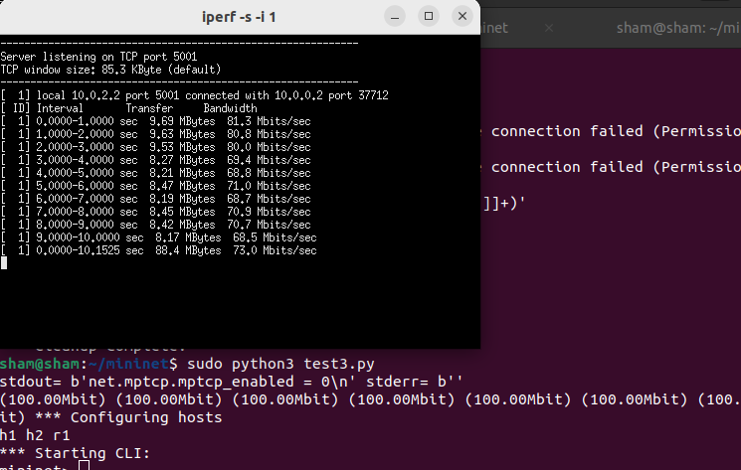

Source=10.0.0.2

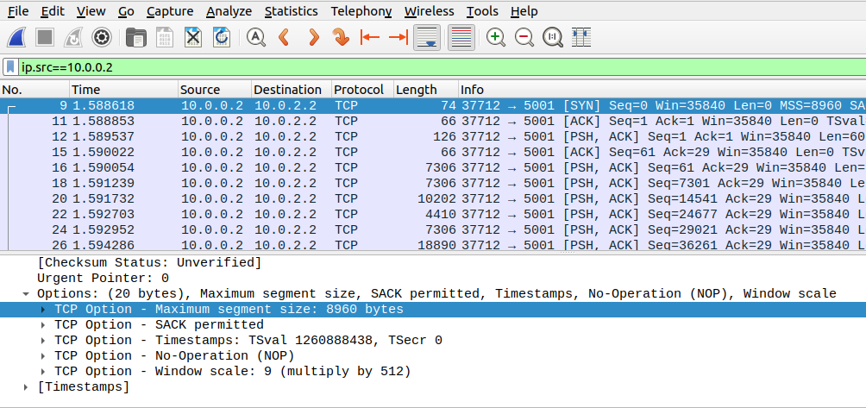

MPTCP=1

Bandwidth=100mbps

h1-eth0 mtu 9000

h1-eth1 mtu 576

r1-eth0 mtu 9000

r1-eth1 mtu 576

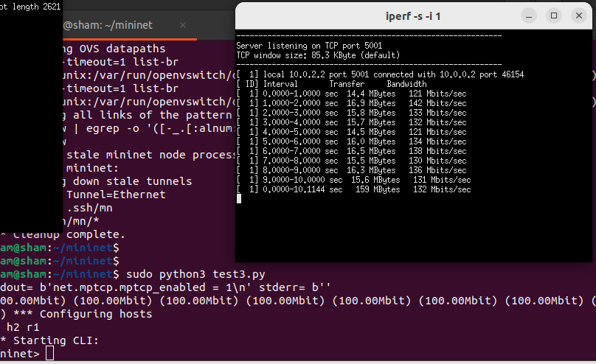

Source= 10.0.0.2

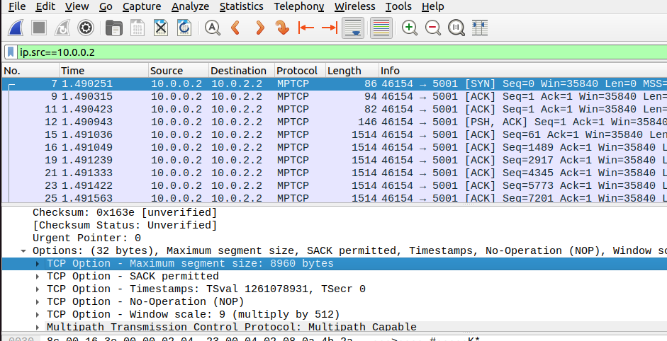

Source=10.0.1.2

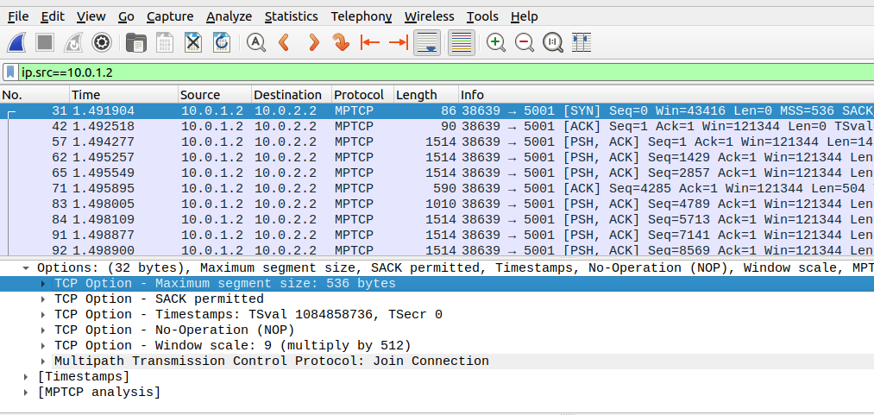

MPTCP=1

Bandwidth=100mbps

h1-eth0 mtu 9000

h1-eth1 mtu 9000

r1-eth0 mtu 9000

r1-eth1 mtu 9000

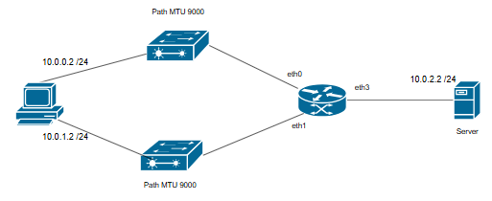

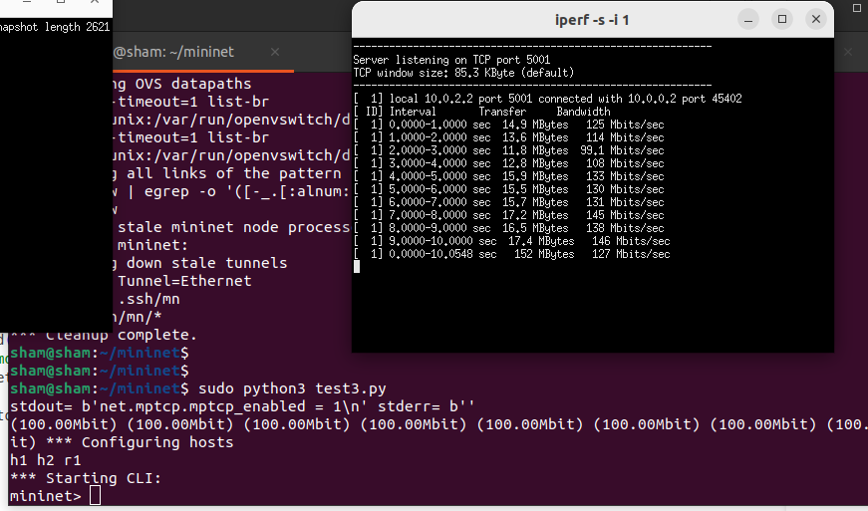

Source=10.0.0.2

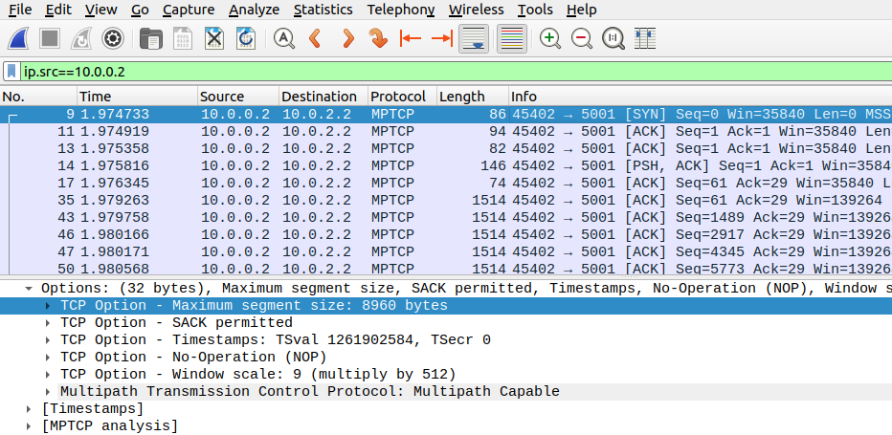

Source= 10.0.1.2

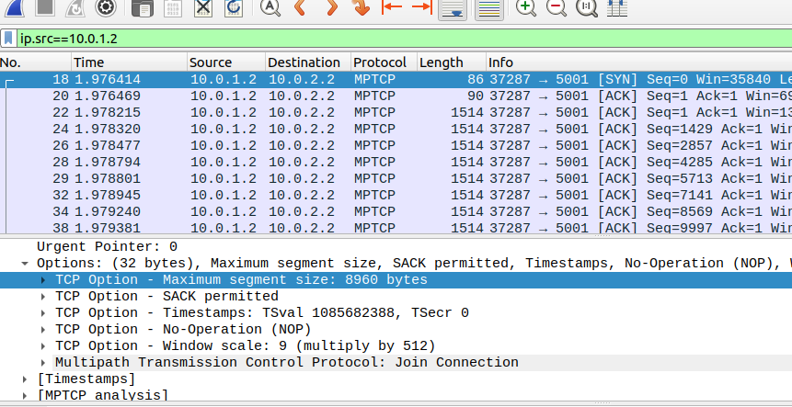

MPTCP=1

Bandwidth=100mbps

h1-eth0 mtu 576

h1-eth1 mtu 576

r1-eth0 mtu 576

r1-eth1 mtu 576

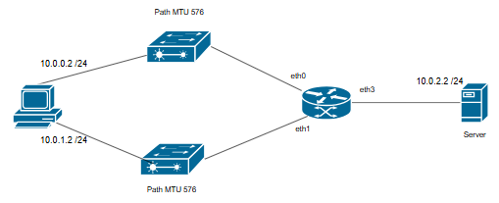

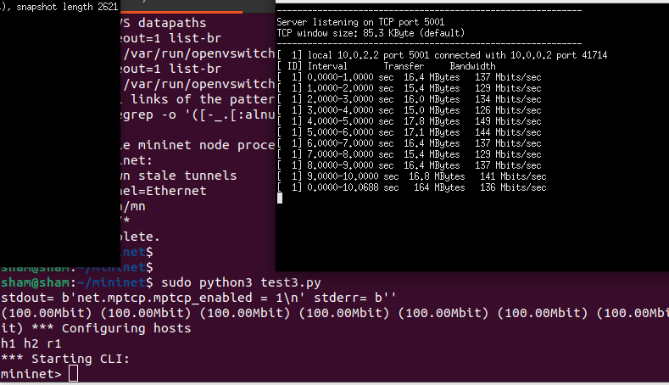

Source=10.0.0.2

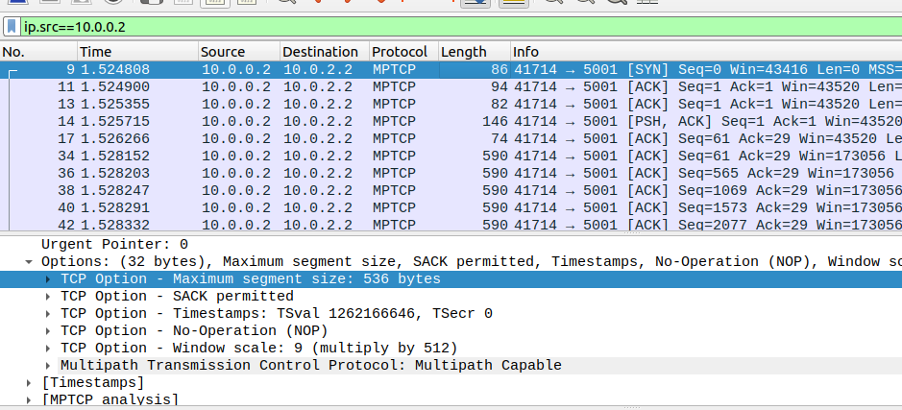

Source=10.0.1.2

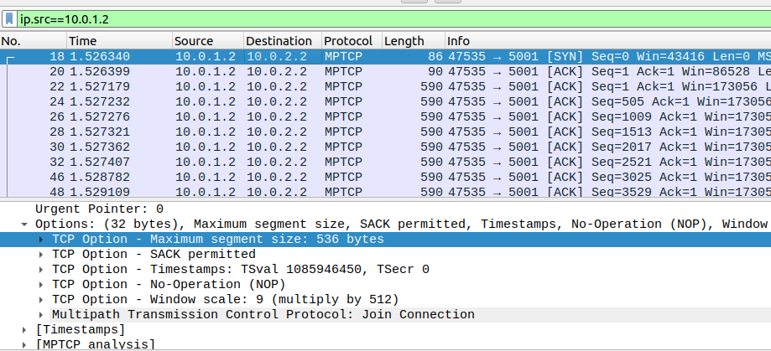

MPTCP=0

Bandwidth=100mbps

h1-eth0 mtu 9000

h1-eth1 mtu 9000

r1-eth0 mtu 9000

r1-eth1 mtu 9000

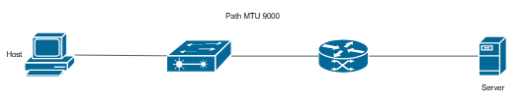

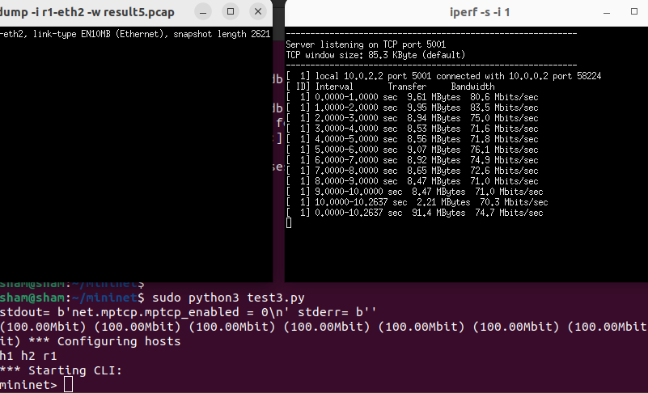

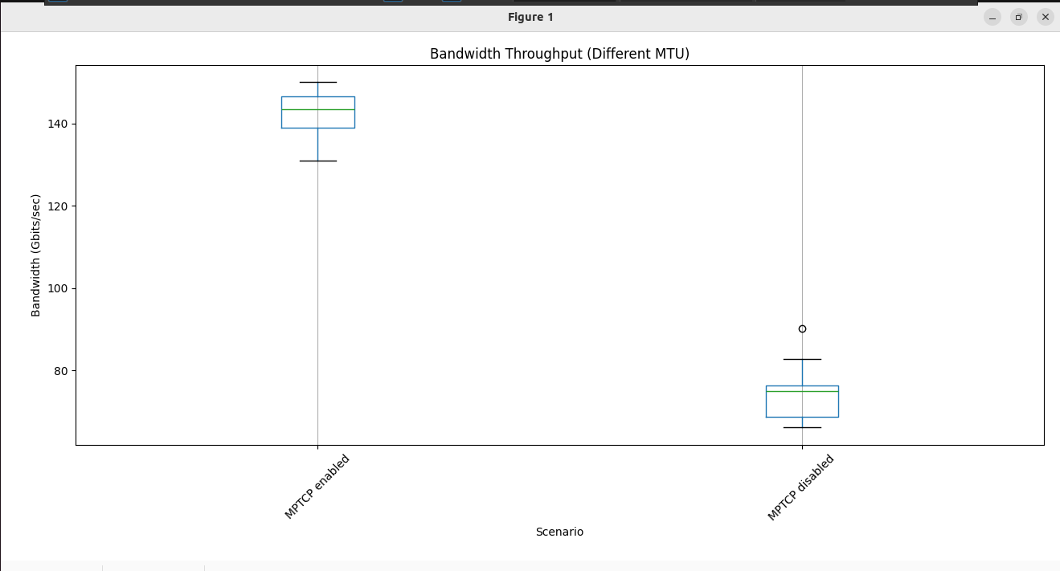

MPTCP =0 , MPTCP=1 with 9000 MTU each

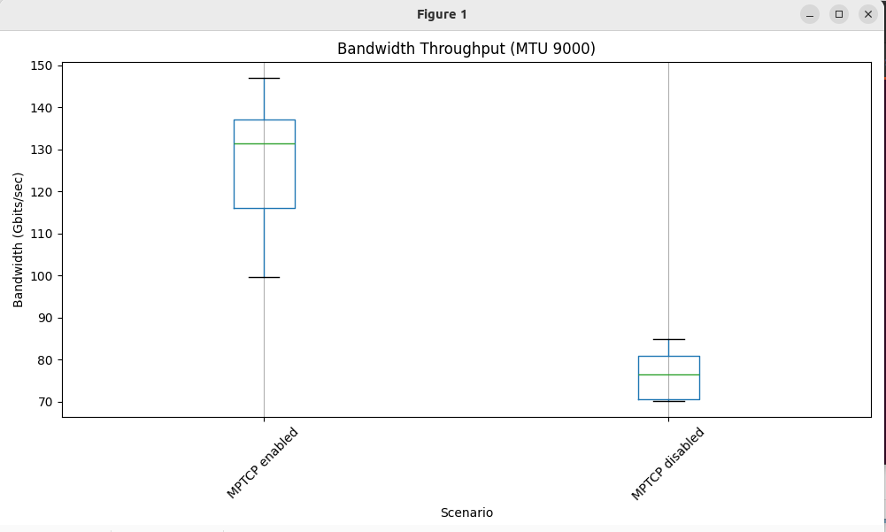

MPTCP enabled both link 9000 MTU vs 576 MTU

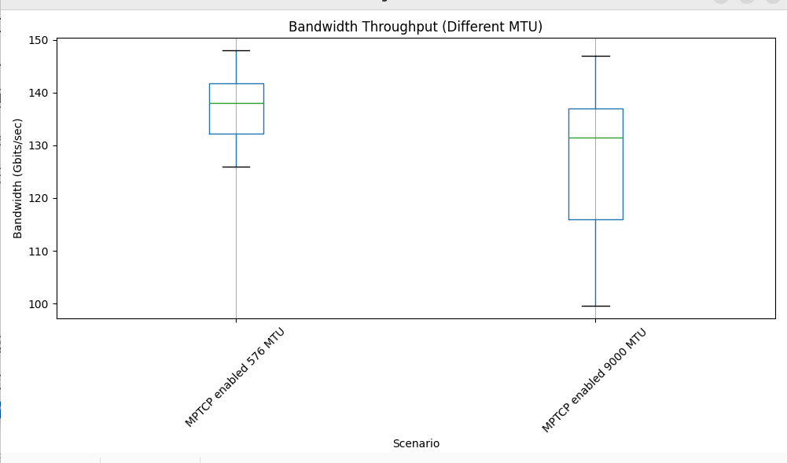

In here I used changing host interface’s MTU.

**Experiment 2**

Bandwidth is not set.

MPTCP=0

h1-eth0 mtu 9000

h1-eth1 mtu 576

r1-eth0 mtu 9000

r1-eth1 mtu 576

in here host 1 knows his interfaces’s MTU. Path MTU discovery??????

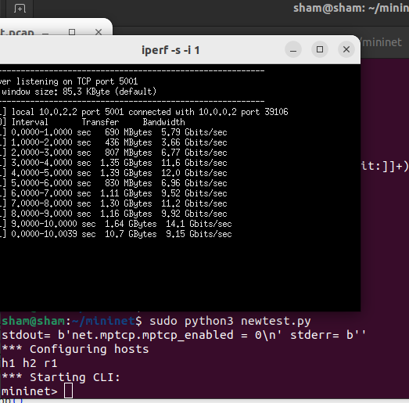

Bandwidth is not set.

MPTCP=1

h1-eth0 mtu 9000

h1-eth1 mtu 576

r1-eth0 mtu 9000

r1-eth1 mtu 576

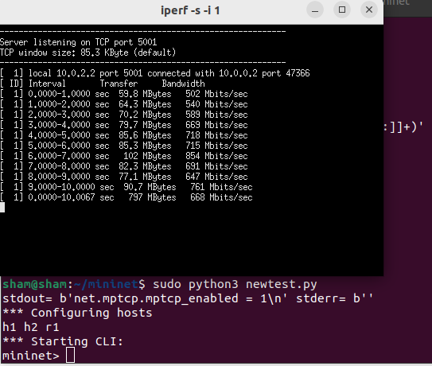

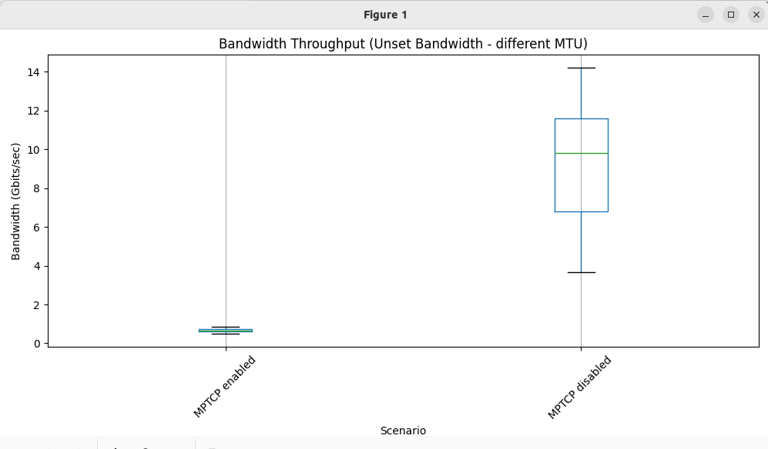

Bandwidth must be set. Otherwise it does not give proper results. Even when checking different bandwidth rather than path MTU, MPTCP must work better than TCP. When removing bandwidth, it didn’t give such results. Conclusion is bandwidth must setup for even simple test.

# Day 3





**Experiment 3**

h1 interface 1 mtu 9000")



h1 interface 2 mtu 9000")

r1 interface 1 mtu 9000")

r1 interface 2 mtu 576")

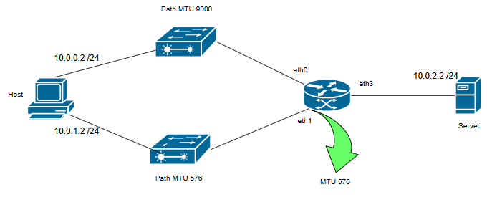

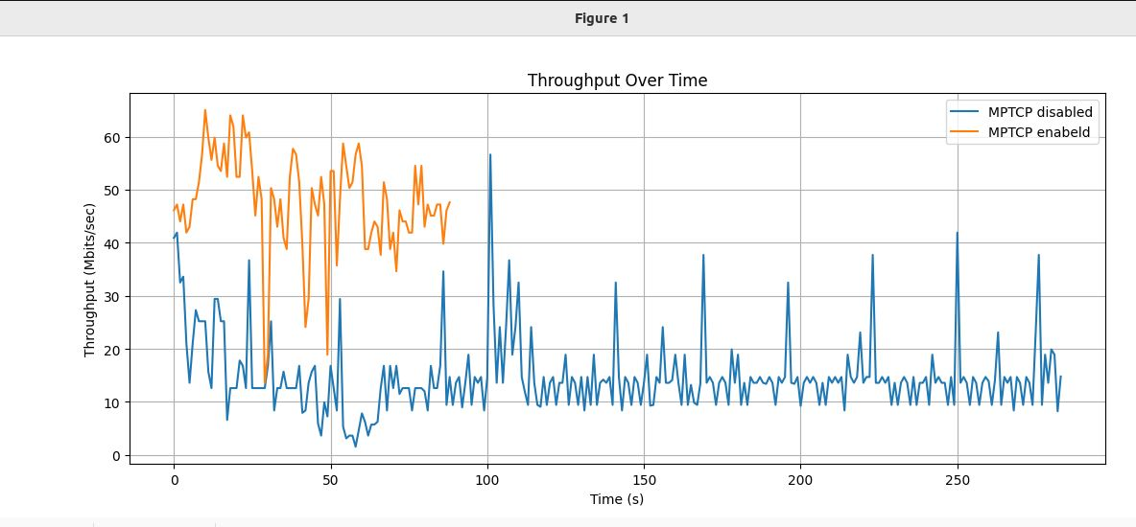

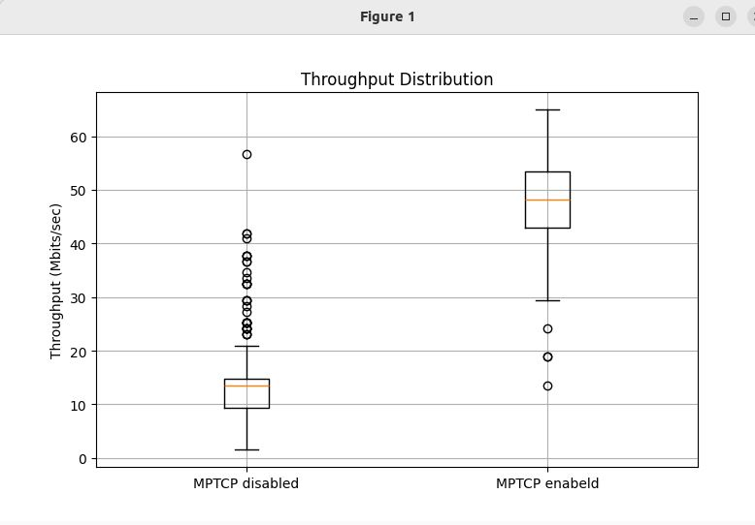

Packets capture from router interface 3 (r1<->Server). But when investigate pcap files

When MPTCP enabled  
source = 10.0.0.2 SYN=8960

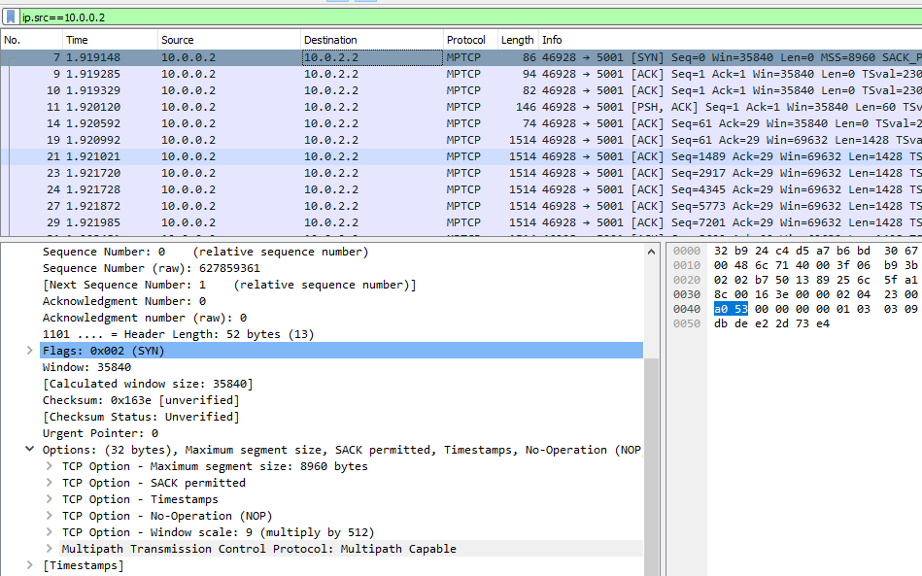

Data size= 1428

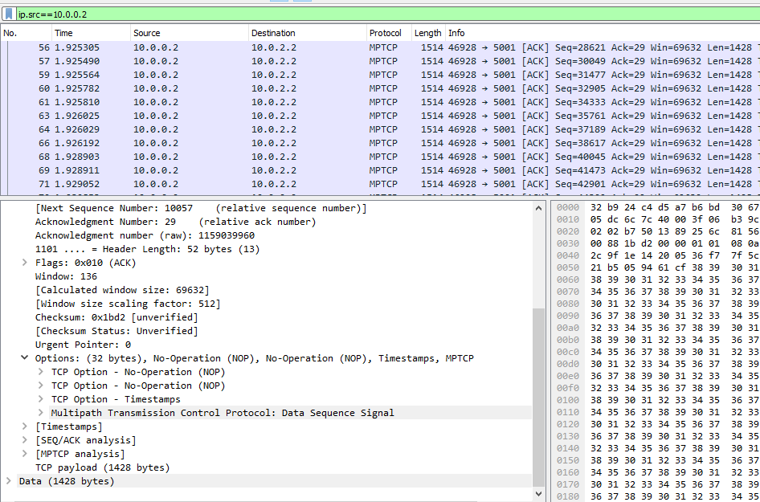

Source= 10.0.1.2 MP JOIN

SYN = 8960

No packet capture records from second IP

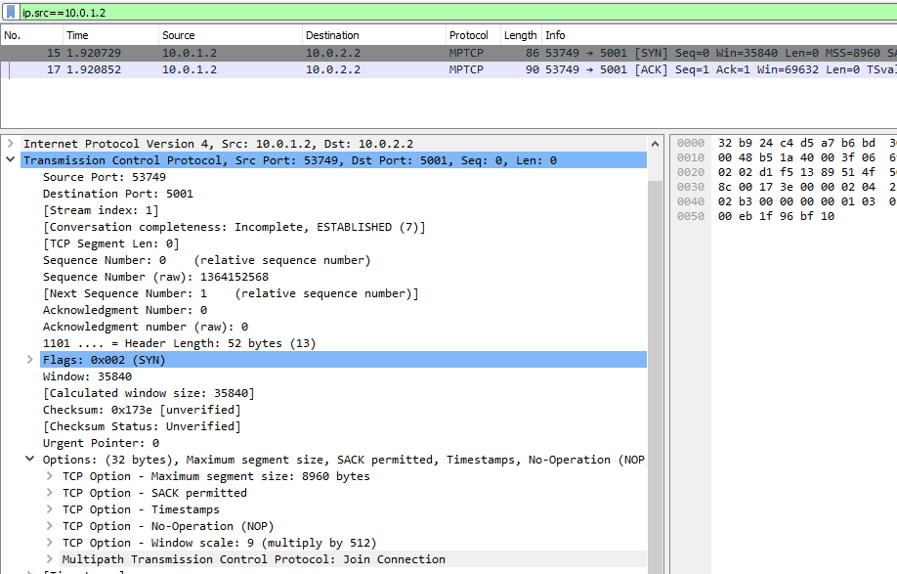

TCP=1

MPTCP=0

Source= 10.0.0.2

SYN=8960

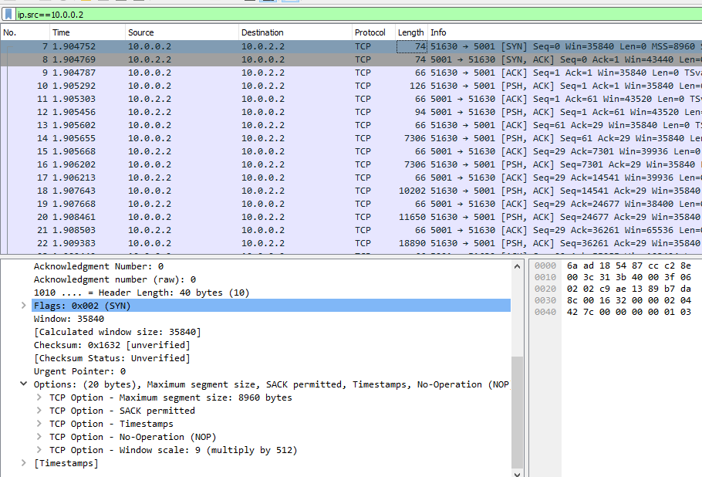

Source=10.0.1.2 . no records

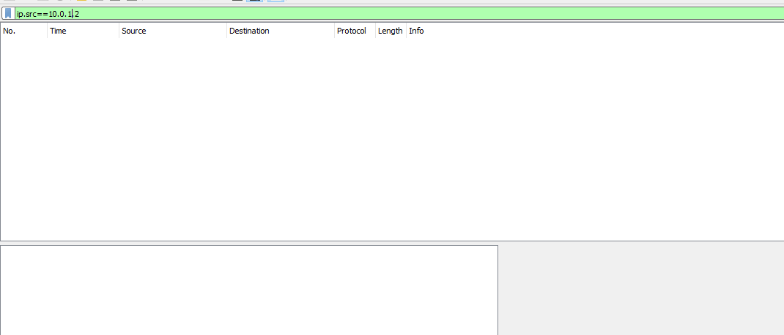

# Day 4

MPTCP =1





R1-eth1 = 576 MTU



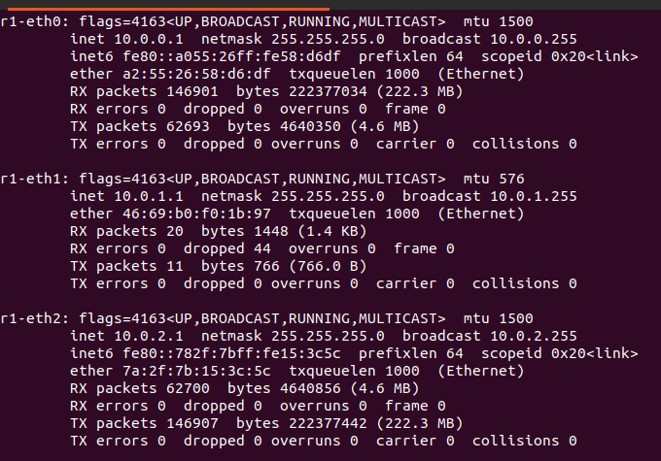

Rest of are default 1500

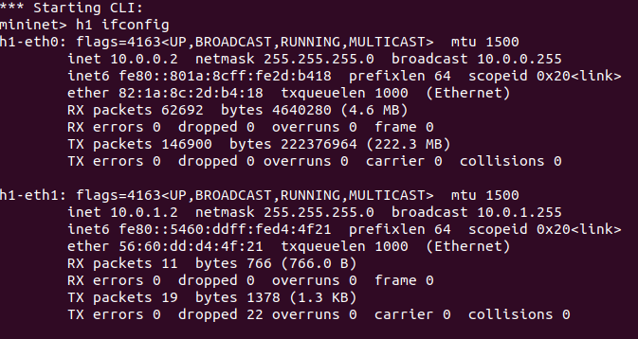

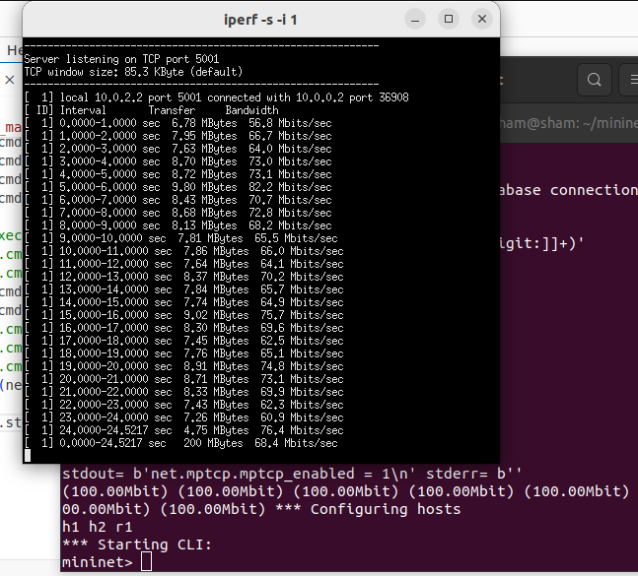

Source = 10.0.0.2

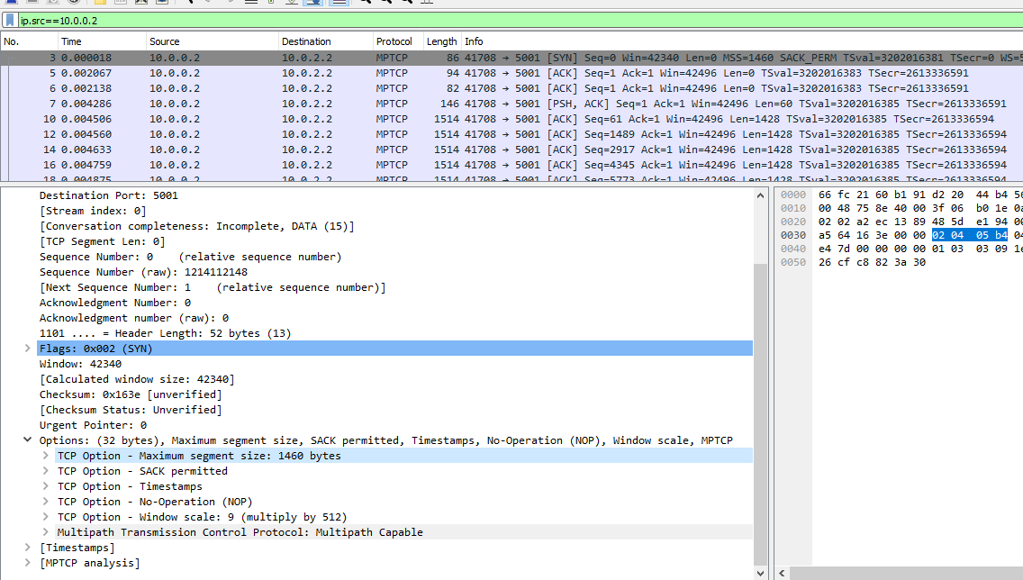

Source= 10.0.1.2

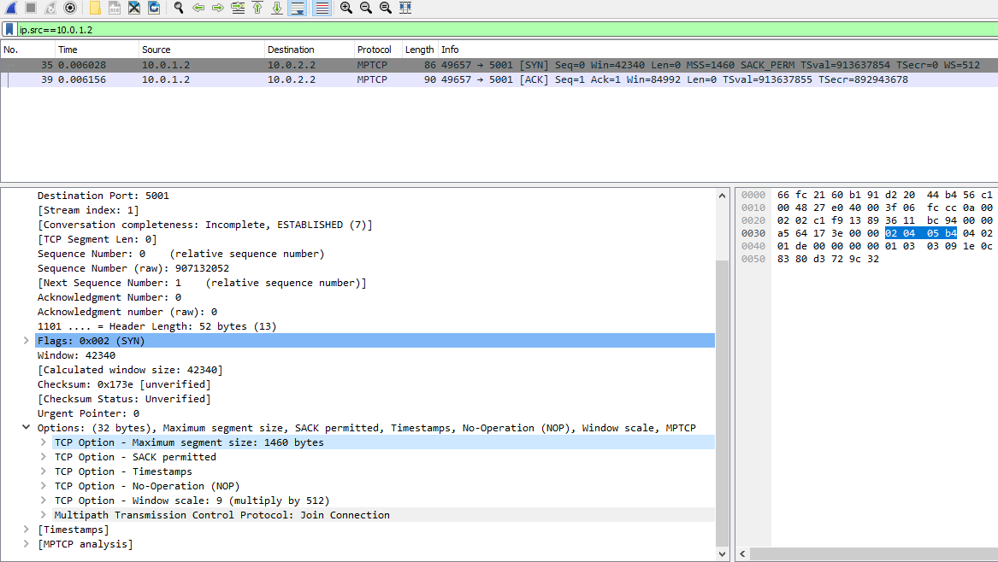

TCP

Source= 10.0.0.2

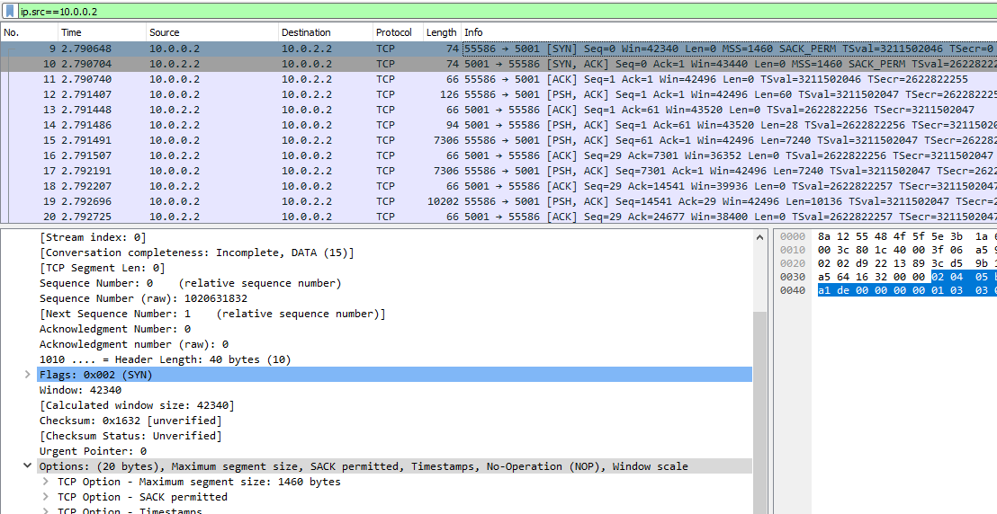

source= 10.0.1.2

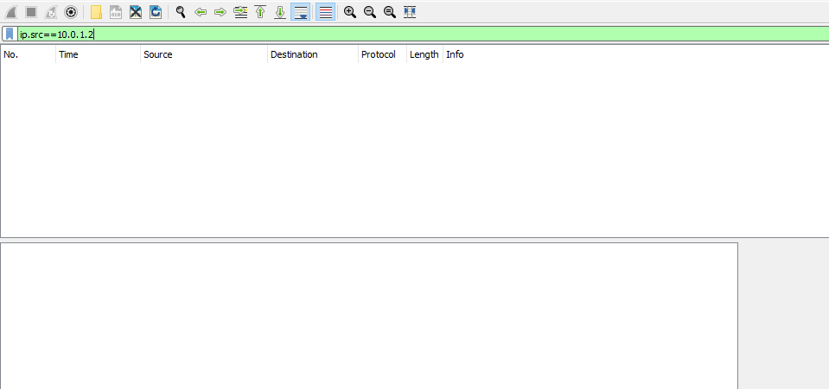

TCP , there is no usage of 2nd link

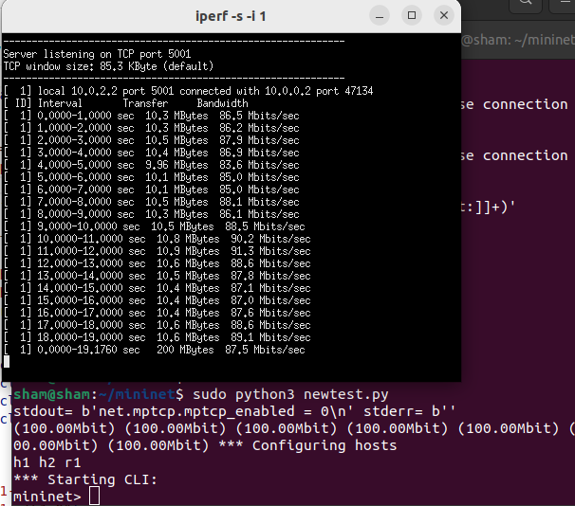

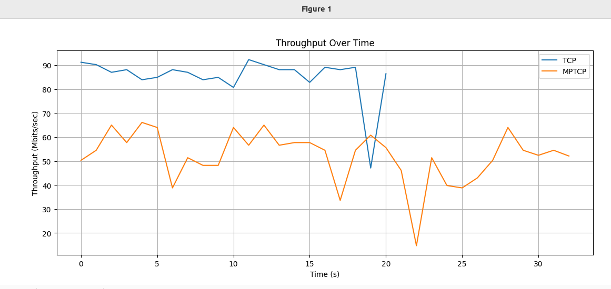

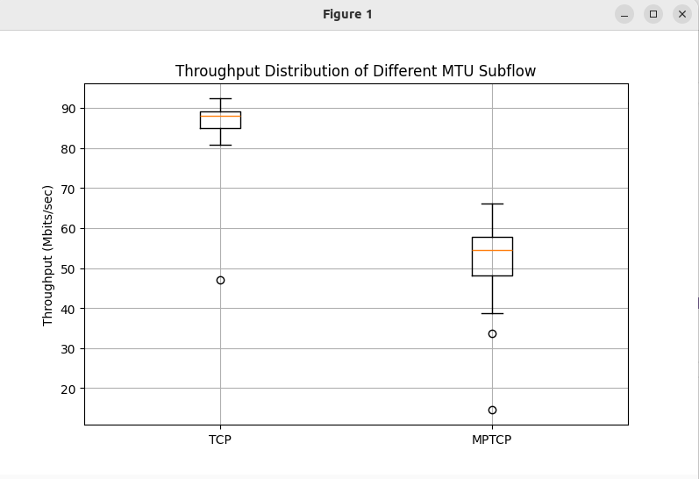

Up to now in MPTCP, 2 link is not utilized. MP join opt not work. Path MTU of 1st link is 1500. Path MTU of 2nd link is 576 due to MTU of router eth1 interface.

# Day 5

## Experiment 1

MPTCP=1 MTU 9000 all

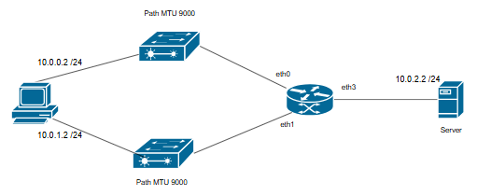

MPTCP =1 MTU 9000 vs 1500

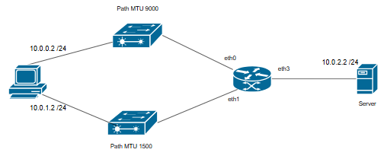

TCP =1 MTU 9000 vs 1500

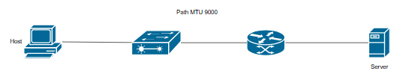

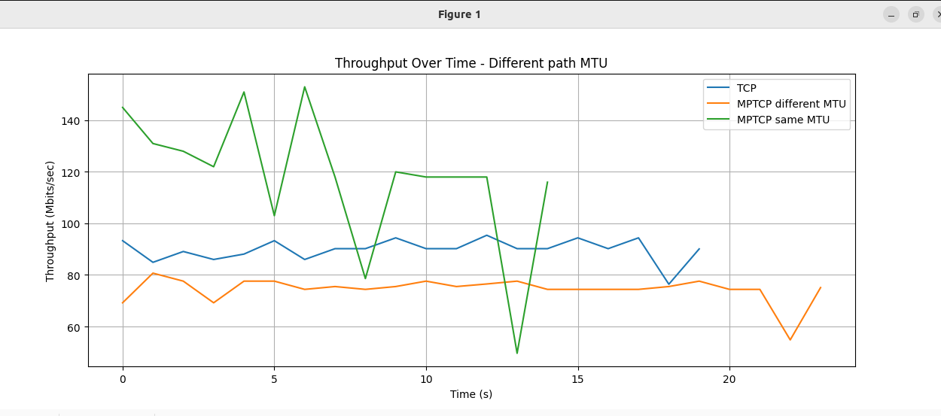

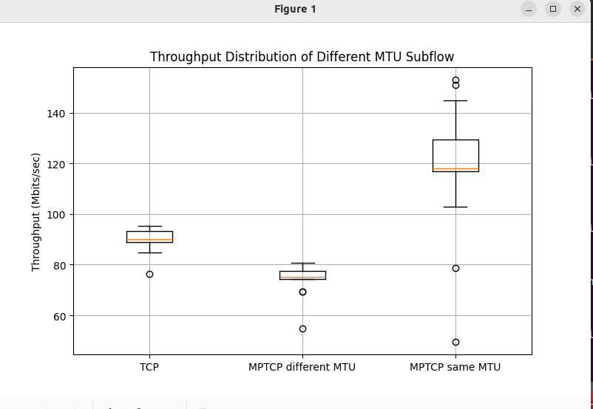

MPTCP =1 MTU 9000 vs 1500

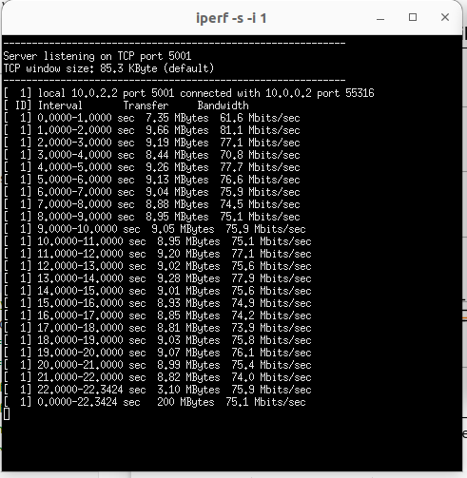

TCP =1 MTU 9000 vs 1500

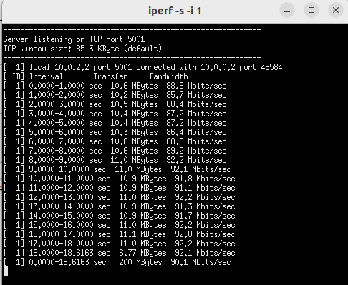

MPTCP=1 MTU 9000 all

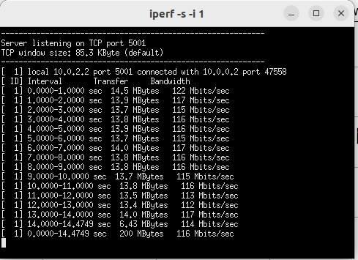

## Experiment 2

TCP (MPTCP=0) diff MTU 9000 vs 1500

MPTCP=1 diff MTU 9000 vs 1500

MPTCP=1 9000 MTU all

MPTCP=1 1500 MTU all

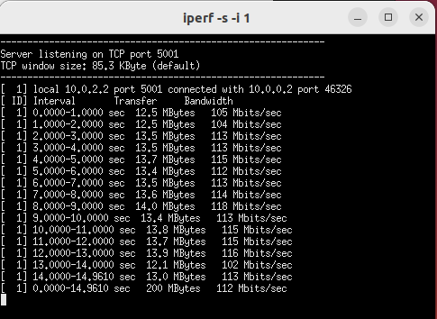

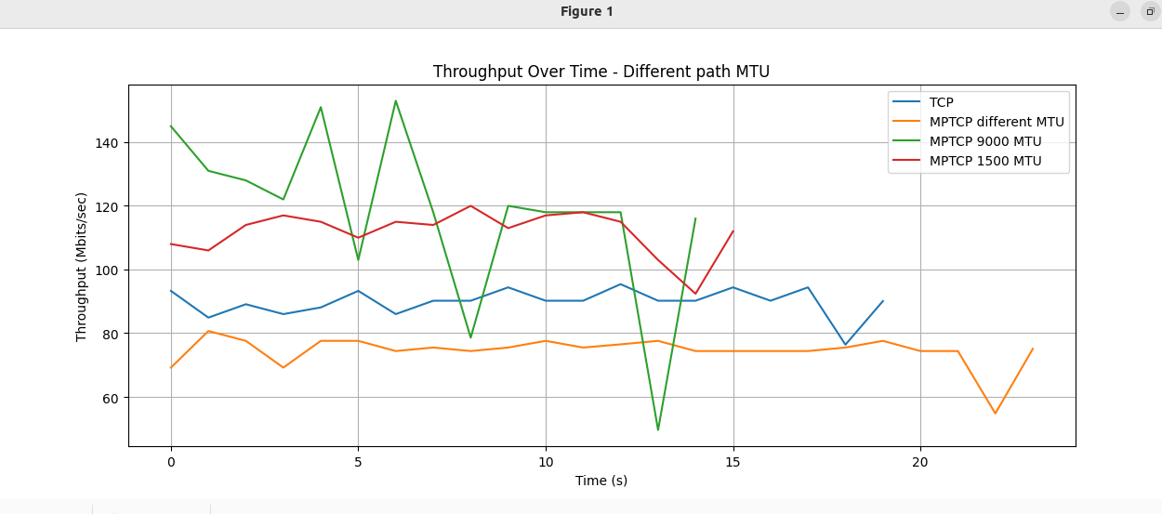

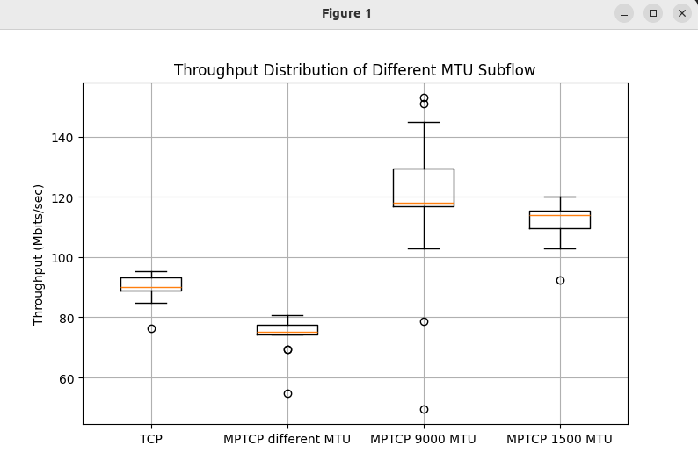

# Day 6

Link 1 1500MTU

Link2 9000MTU

TCP

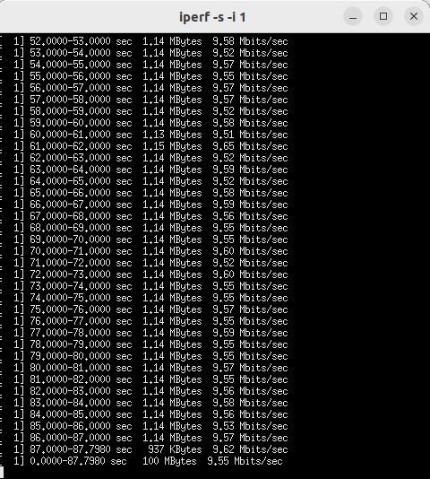

MPTCP

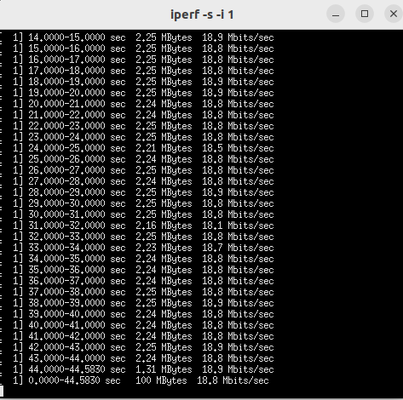

Link 1 pcap- uses exact 1500 MTU as usual

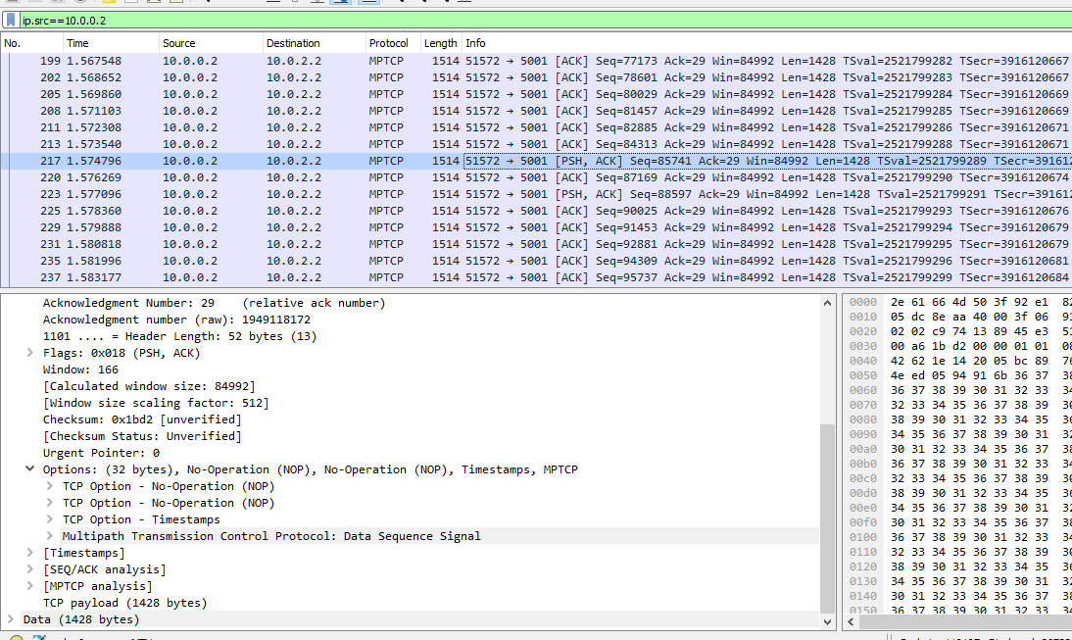

Link 2 pcap- it uses only 1500MTU instead of 9000MTU

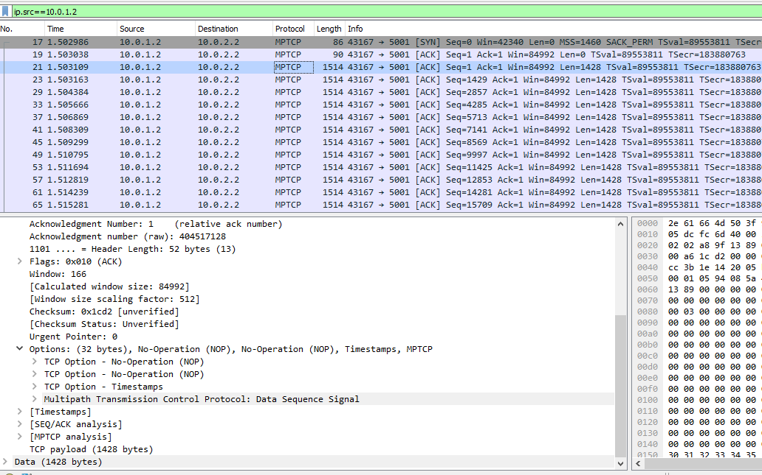

Day 7

Create TCP link to check whether path MTU is configured correctly

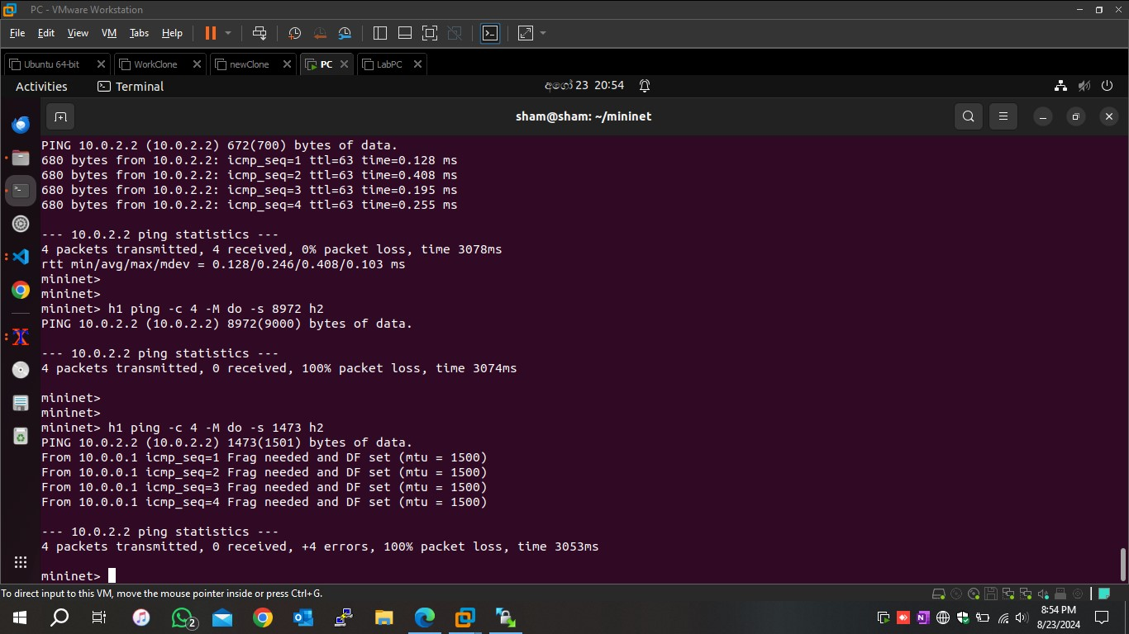  
  
[pcap file](https://drive.google.com/file/d/1XND8iA3f1ZVTHDUK4m0ahKEktxy7paVb/view?usp=drive_link)

Create bottleneck in MPTCP topology

[bottelneck pacap](https://drive.google.com/file/d/1EQpNJH14IIqUnLN3NJCahFm-UsHr2Rjp/view?usp=drive_link)

End host bottleneck

[End host low MTU pcap](https://drive.google.com/file/d/1ElFBB-uAL4fIngIPutKsHiP1KH_zdyEf/view?usp=drive_link)

Self bottleneck low mtu pcap

[self low mtu pcap](https://drive.google.com/file/d/1M9SfnAPE3SVrfh3d4H4gAJnxLKqTEfEz/view?usp=drive_link)

# Interim

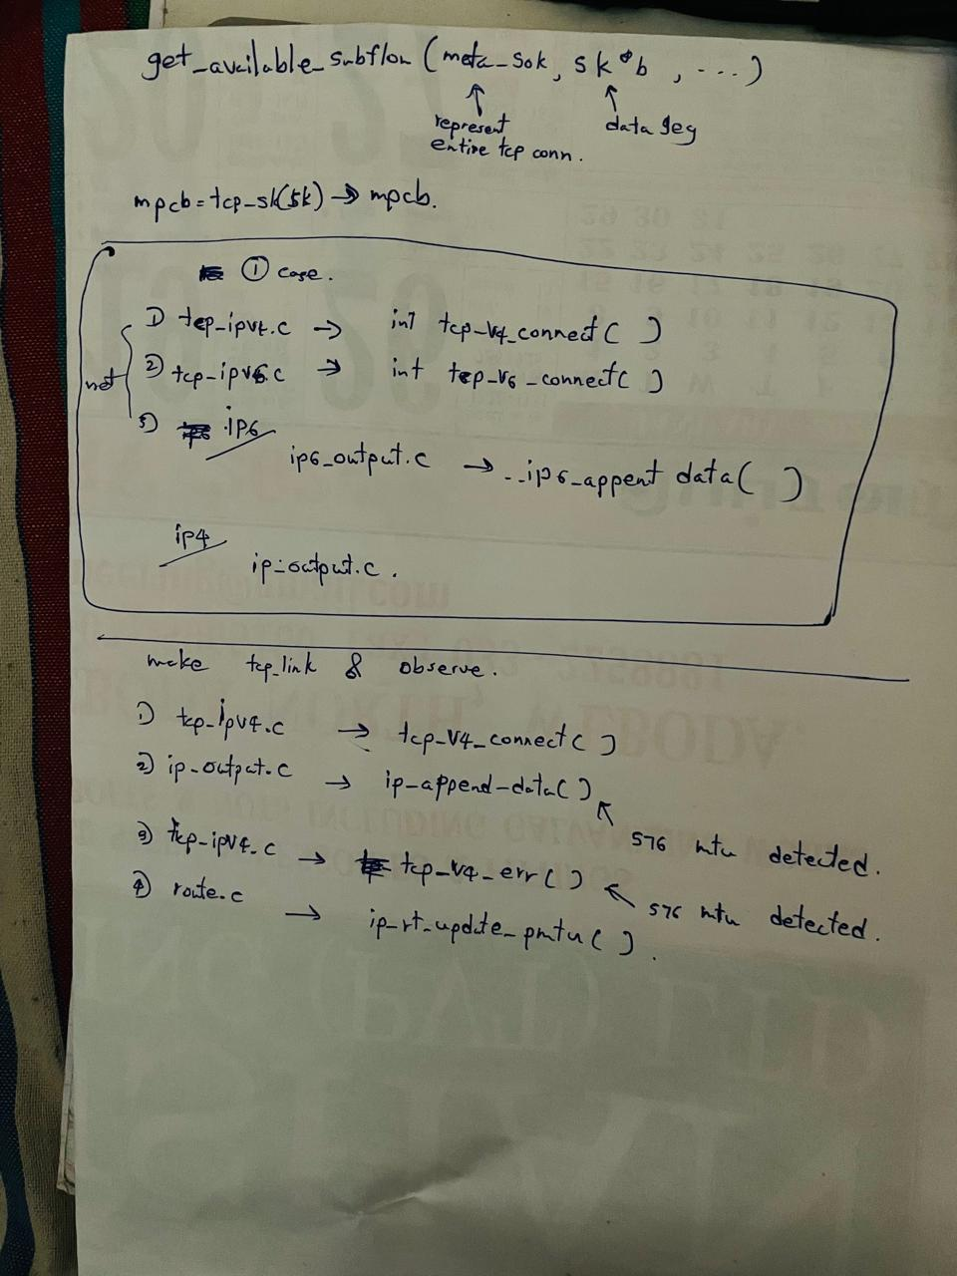

**Objectives**

Make tcp connection to catch mtu detection

Create mininet script- establish single tcp link

* Change PMTUs

Which point mtu detection does

Kernal print MTUs

Which files involving to do this

-----------------------------------------------------------------------------------------------------------------------------

## Day 1

Mininet single tcp script , interfaces up as ipv6 .

Ipv6 – > addrconf.c –> func addrconf_notify

Kernel log is

View log file [log](https://drive.google.com/file/d/1j1CNXIVNd4HG0prEY_i3h7GfCFRDCchn/view?usp=sharing)

View kernel msg - [kernel](https://drive.google.com/file/d/1NCXRR8qpDFt3b44eDjEYLmsQVsgCx7Za/view?usp=sharing)

-----------------------------------------------------------------------------------------------------------------------------

## Day 2

Finding packets size when making IP header for data segment

net/ipv4/ip_output.c

ip_build_and_send_pkt function building IP header and sending individual IP packets,

In net/ip.h

PMTU defined as 65535U

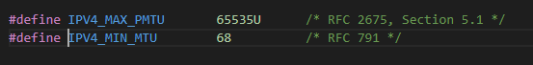

Print skb len in kernel to check what is there. net/ipv4/ip_output.c -- ip_build_and_send_pkt()

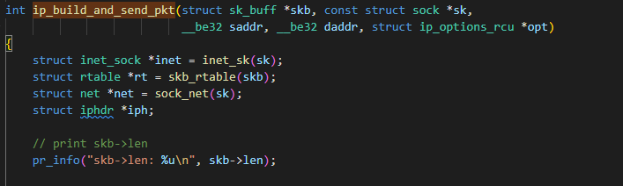

Result

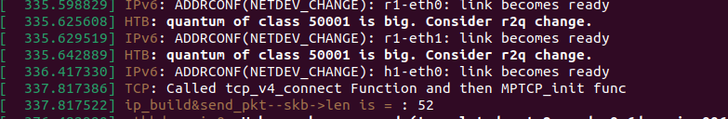

It print as 52

But data is not transferred

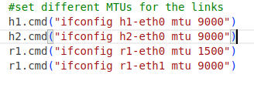

When mtu size change to 1500 for all

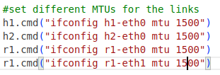

It transferred data.

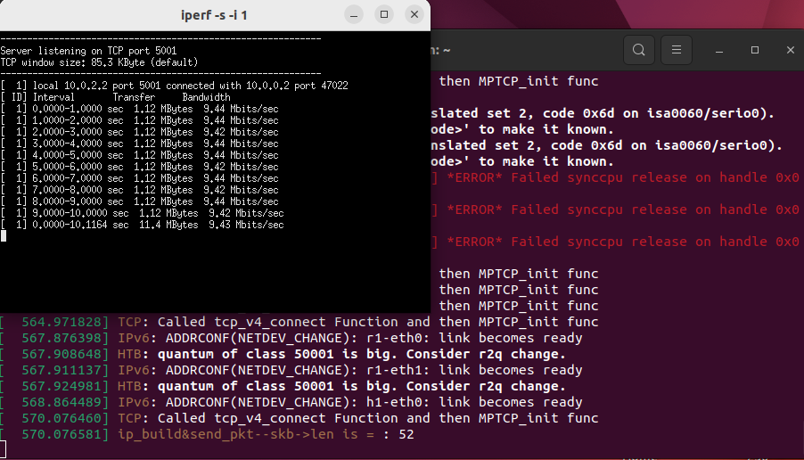

Change MTU to 9000 for all – data transferred

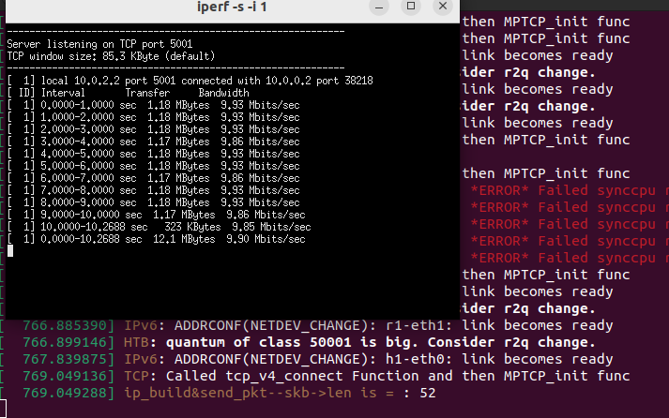

Eventhough interface MTU size 1500 or 9000 skb->len give 52 ?

When create bottleneck data is not transferred

internet note:- tcp_mtu_probing = 2 (Aggressive Probing)

* In addition to responding to "Fragmentation Needed" messages, the kernel periodically sends larger packets to test whether a larger MTU is now supported on the path.
* This "aggressive probing" approach allows the kernel to adjust the MTU up or down, depending on network path changes, which is especially useful for dynamic network environments.
* If a larger MTU becomes possible due to network changes, it improves TCP performance by reducing the number of packets needed to transfer data.

-----------------------------------------------------------------------------------------------------------------------------

## Day 3

Finding where does PATH MTU value decision takes place for stablished tcp link

Enabled PMTUD = sysctl net.ipv4.ip_no_pmtu_disc= 0

Enabled tcp mtu probe = sysctl net.ipv4.tcp_mtu_probing= 1

Need to find where does ICMP handles PMTU values

Ipv4/icmp.c

internet note:- kernel handles ICMP messages in the icmp.c file, where it inspects the type of ICMP error. Specifically, the PMTU-related ICMP error (Type 3, Code 4) indicates that a packet is too large for the next hop’s MTU.

Ipv4/icmp.h/icmp_unreach()

Modified this

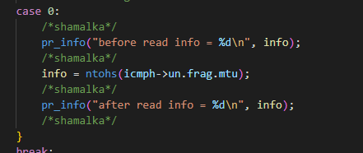

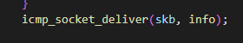

passing the ICMP message along with the MTU info (info) to the transport layer, which adjusts the MTU for future packets.

## Day 4

Mininet script [python file](https://drive.google.com/file/d/15fQPASYRG6HjvexjQ153Ts7L2paTdn6l/view?usp=sharing)

Finally got some results on kernel print

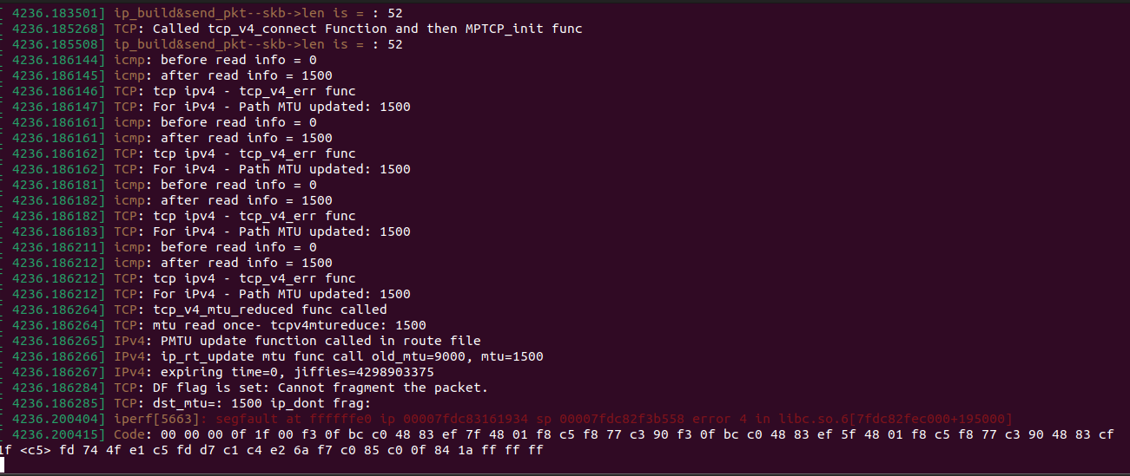Results

Changes:-

Iperf run on 9000 mtu and verbose mode (-d)

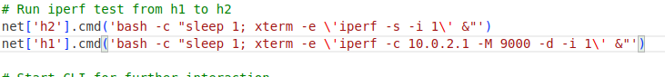

MTU configuaration in mininet

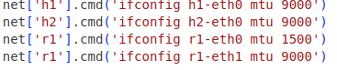

Backend configurations

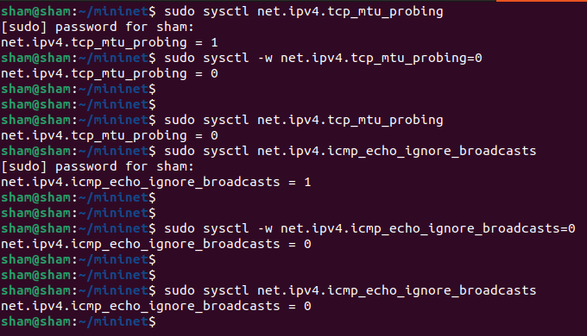

Iperf output

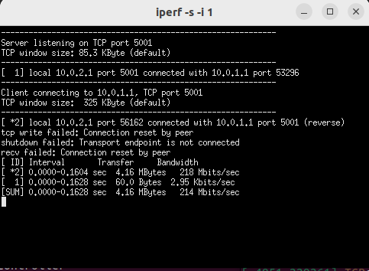

1st run



2nd run



## Day 5

Try to make 1500 MSS in iperf

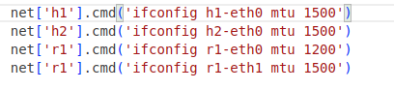

Iperf output

Data is not sending

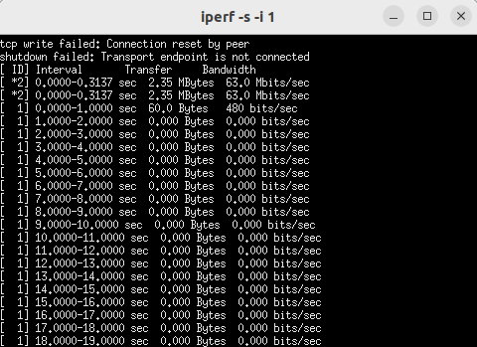

Kernel output

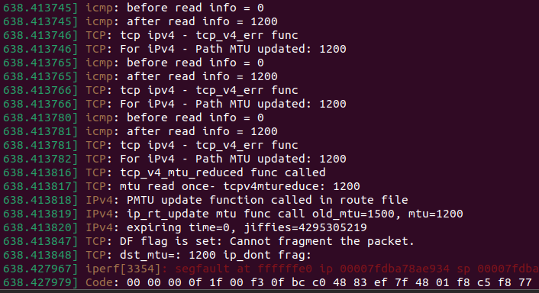

## Day 6

Adding another intermediate router between r1 and h2

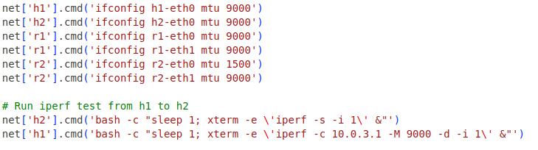

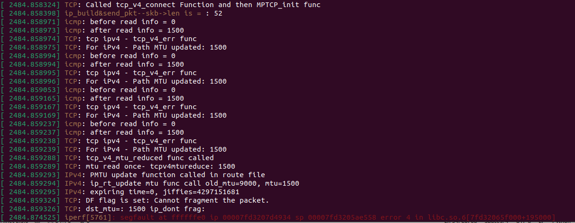

Data sending stop at there in iperf

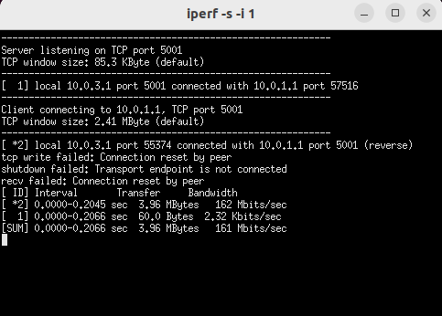

## Day 7

Run MPTCP script

Kernel output

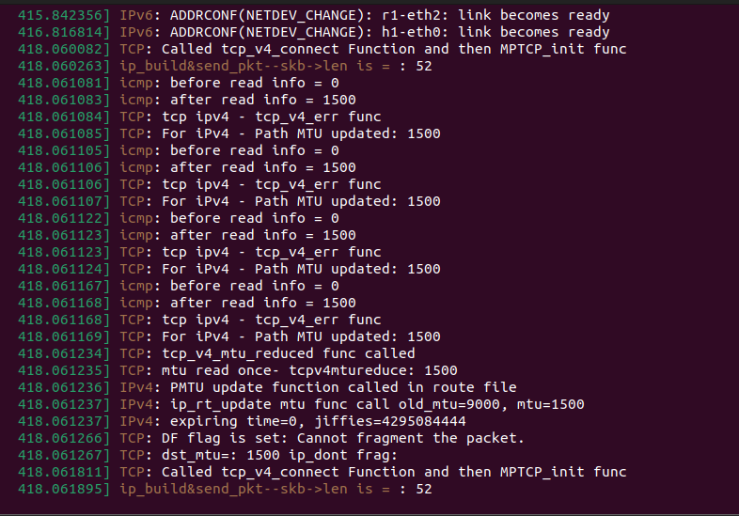

Iperf output

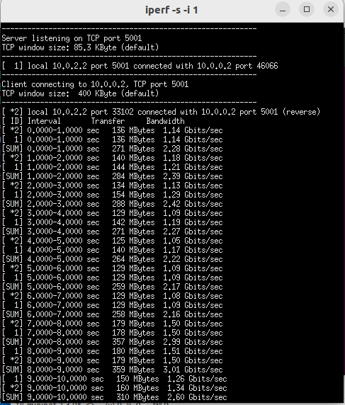

## Day 8

Different MTU for each interface to

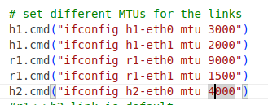

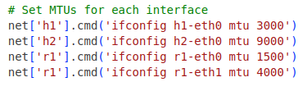

Kernel output

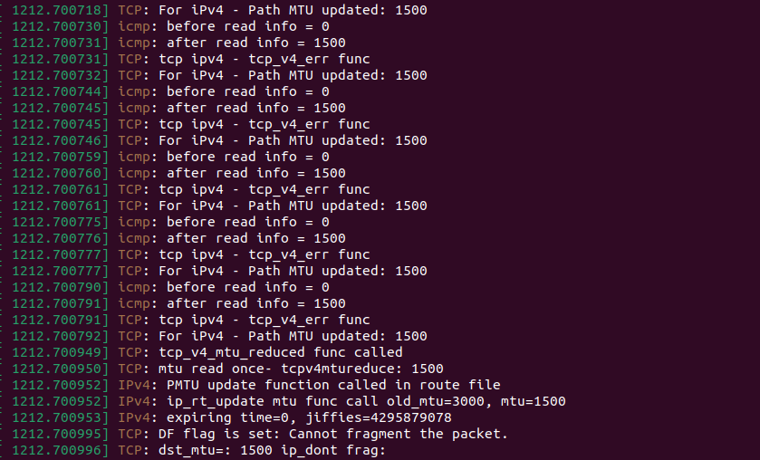

Data is transferred in iperf

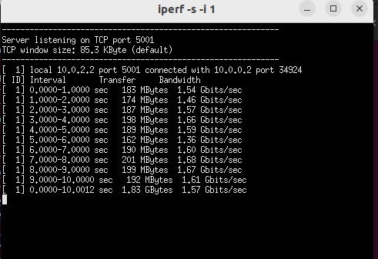

-----------------------------------------

Send 1GB file

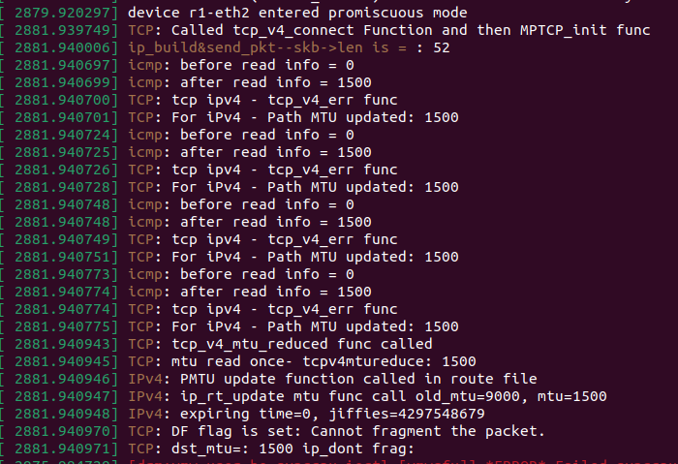

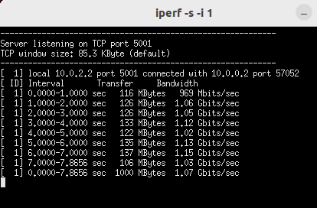

View pcap file – day 8

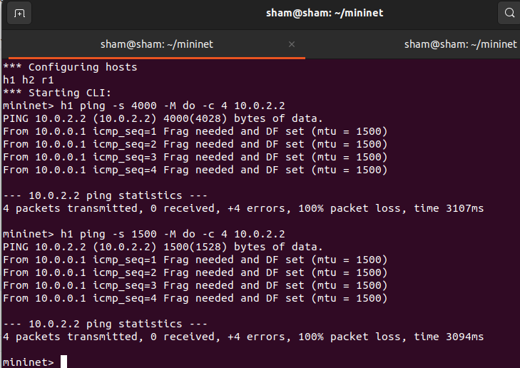

Day 9

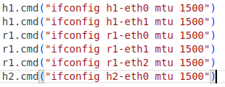

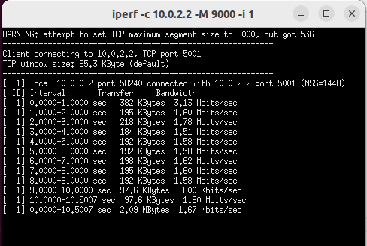

Test 2

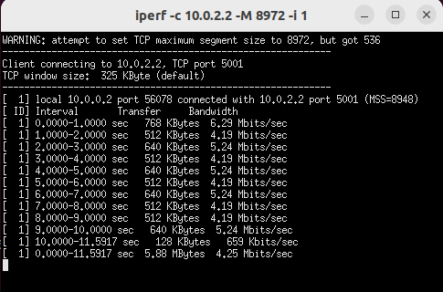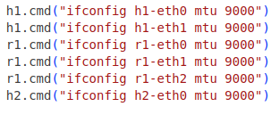

Sudden failure

MPTCP enabled

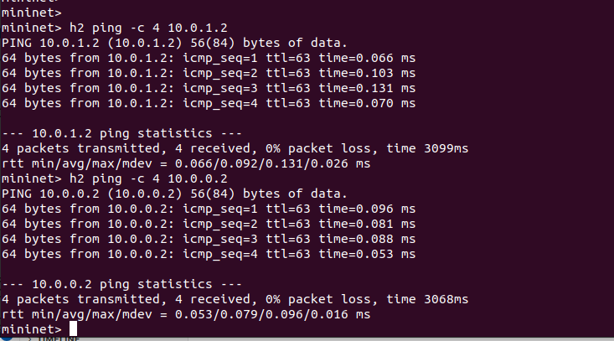

Only create 1st link



There was an error in kernel

Now working kernel is

sham@sham:~/mininet$ uname -r

5.4.230.mptcp

Now it establish both links

Verify that the network topology is configured as expected.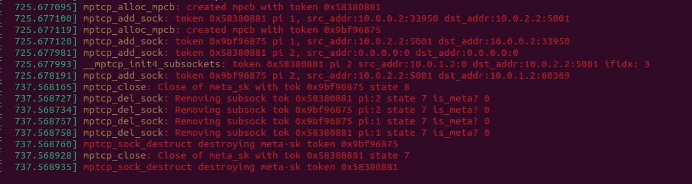

Day 10

Disabled ipv6.

MPTCP is still working fine. This is the packet cap file [pcap](https://drive.google.com/file/d/1YjN9jDJ8GEWKJYYv8kSHgUXSSlxWrJuC/view?usp=sharing).

Before modfy the kernel, run the bottleneck mtu test again.

Sending 100MB

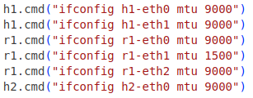

Iperf result

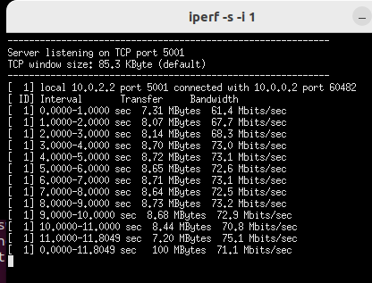

Nothing printed on kernel

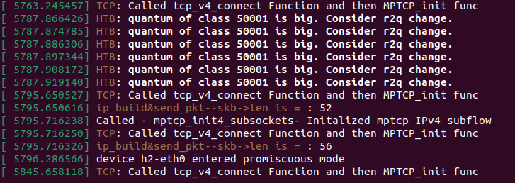

------------------------------------------------------------------------------------------------------------------------

Now working on path MTU info of subflows.

Day 11

Modified the kernel to print some info related to MPTCP.

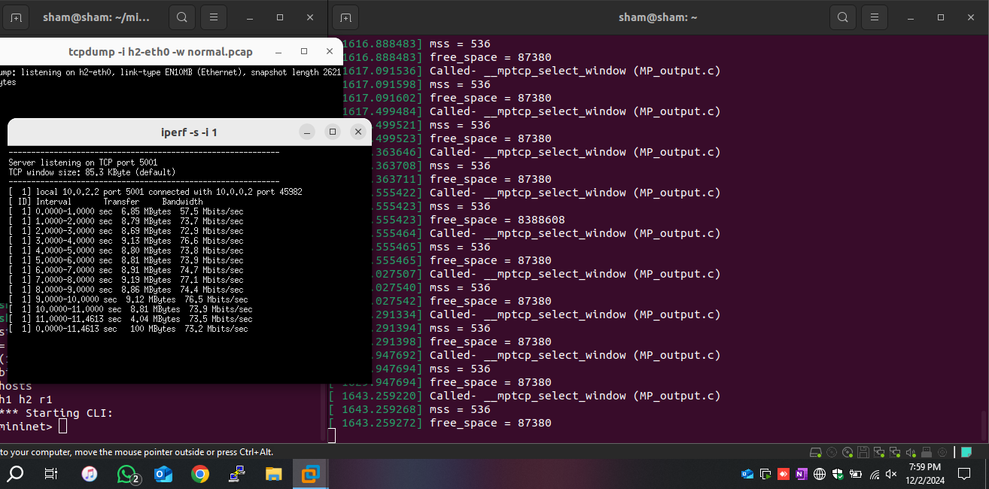

Day 12

According to test results. There is 536 MSS which is not expected one. Other one is 8936 MSS which is supposed to be. Need to find out where from that 536 MSS came. But the default MSS got as 8936.

final returned mss= 8928 on mptcp_current_mss func

default mss=8936

Subflow Address: 000000001d538fb6, MSS = 8928, Free Space = 8386688

Subflow Address: 00000000b1d5b55a, MSS = 536, Free Space = 87380

Subflow Address: 000000002923c0b9, MSS = 536, Free Space = 87380

Subflow Address: 0000000011c6d664, MSS = 536, Free Space = 8388608

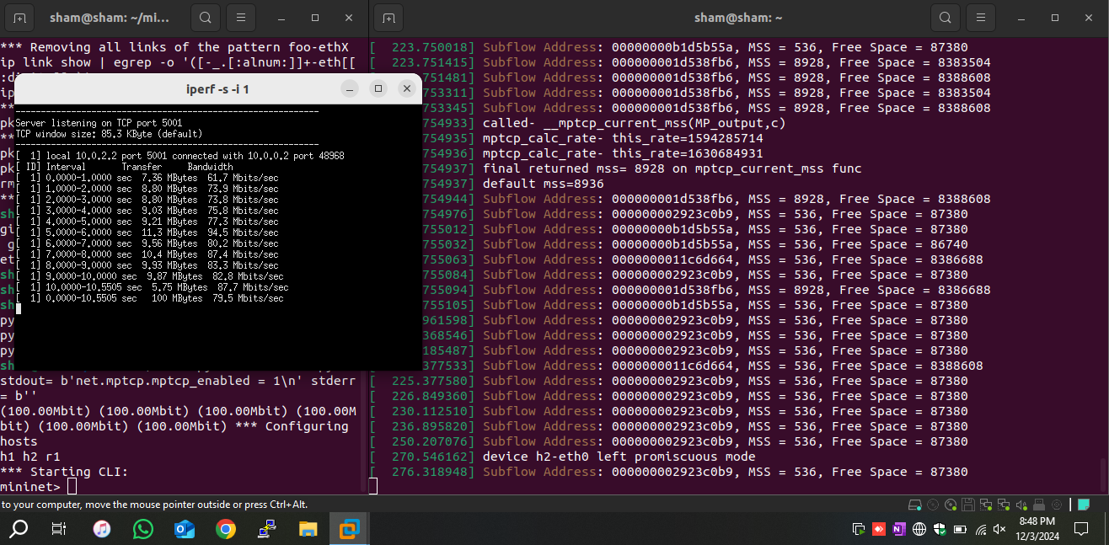

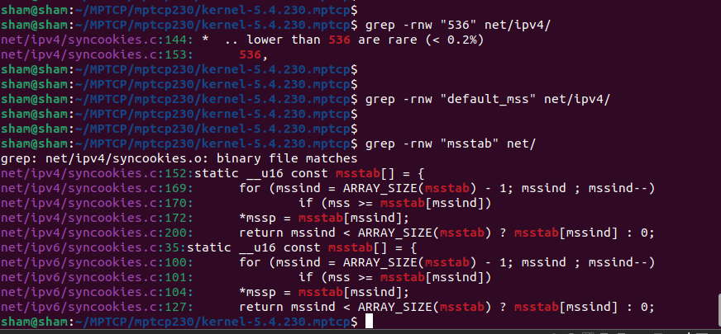

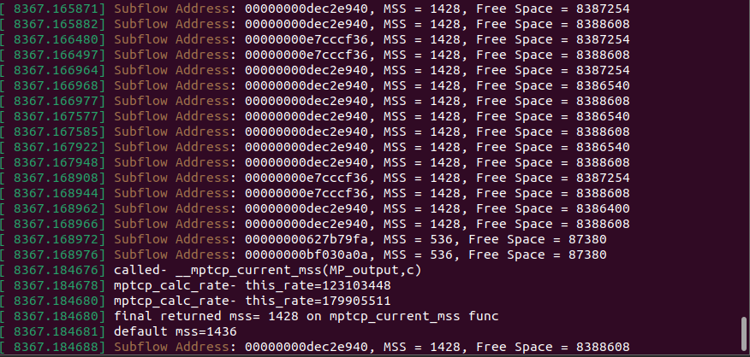

Day 13

MTU probe return -1 which does not enabled correctly. As logs says it was due to snd_cwnd < 11 (default was 10)

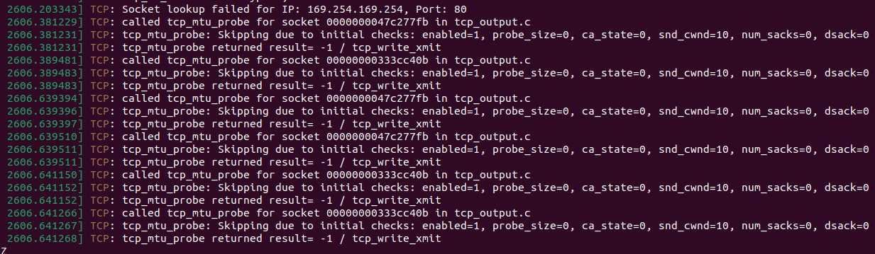

Trying to increase window size. Default was 10. I put to 12

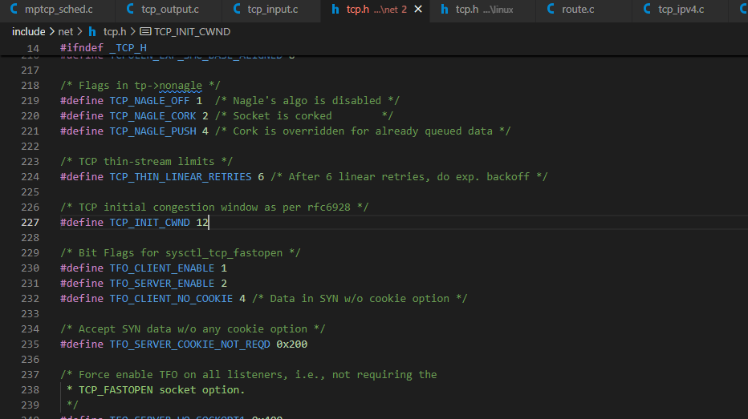

Day 14

Bad day. ☹Added bit map to take logs of each subflow. Bit after that iperf shows data transferring is not happening.

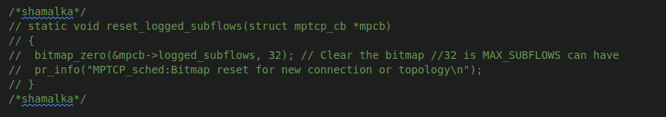

Day 15

Recover the issue. Back to working mode 😊.

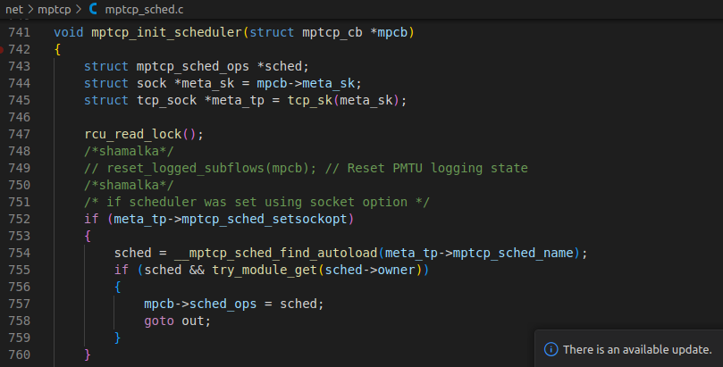

Day 16

Internet references

**MPTCP MSS Selection**:

* The function mptcp_current_mss and the related helper functions calculate the MSS value used by MPTCP for sending data. Specifically, __mptcp_current_mss iterates through all subflows and chooses the MSS based on the one that can provide the highest throughput, considering congestion window, RTT, and other factors. It ensures that the MSS used for MPTCP is appropriate across multiple subflowsMTU Handling**:
* Path MTU discovery for subflows is not explicitly visible in the file, but the selection of MSS is indirectly related to the path MTU, as it determines the largest possible segment that can be sent on a path without fragmentation. In functions like mptcp_xmit_size_goal, the MSS values for subflows are adjusted to avoid splitting segments, which indirectly manages path MTU compatibility .

**Adjustmen

* Inside mptcp_xmit_size_goal, the MSS of each subflow is considered when determining the maximum transmission size. If a subflow has a smaller MSS than others, this will impact the overall MSS for MPTCP, affecting the packet segmentation across subflows .

**MPTCP's Use of Subflow MSS**:unctions like mptcp_calc_rate and mptcp_for_each_sub compute throughput estimates for each subflow based on its MSS and other factors like RTT. The MSS is used to optimize the transmission rate for MPTCP, especially when combining subflows .

**Paasch, C., et al. (2015)**: "Multipath TCP: From Theory to Practice"

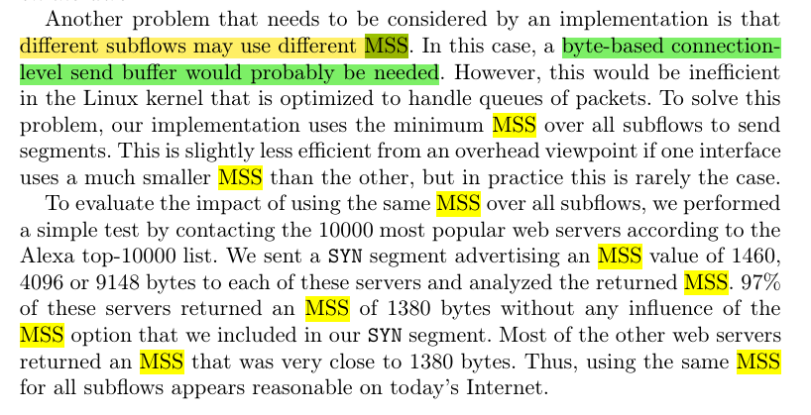

Day 17

Test1

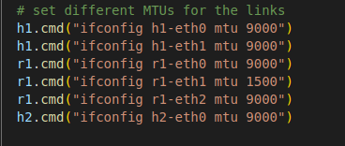

Results

Use 9 test. Only

10.0.0.2 -> 10.0.2.2 use 9000MTU

10.0.1.2 -> 10.0.2.2 didn’t use

Test2

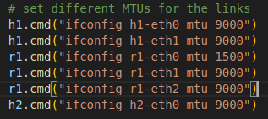

Results

Use 10 test. Only

10.0.1.2 -> 10.0.2.2 use 900MTU

10.0.0.2 -> 10.0.2.2 didn’t use

Test3

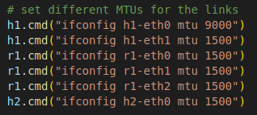

Results

Use 11test.

10.0.1.2 -> 10.0.2.2 use 1500MTU

10.0.0.2 -> 10.0.2.2 use 1500MTU

Day 18

**Challenges and Considerations**

1. **Standard MPTCP Behavior**:
   * The current MPTCP implementation uses a **unified MSS** for all subflows, calculated based on the smallest PMTU. This approach avoids fragmentation across subflows and simplifies retransmission and packet reordering.
2. **Data Sequencing in MPTCP**:
   * MPTCP maintains a **connection-level sequence number** for data transmitted across subflows. If subflows use different MSS values, segment sizes could vary, complicating sequence number management, packet reassembly, and reordering at the receiver.
3. **Fragmentation Risks**:
   * If a larger MSS is used on a subflow with a higher PMTU, but packets are routed through an intermediate link with a lower MTU (due to dynamic network conditions), fragmentation could occur. **PMTUD** must be robust to dynamically detect and adjust MSS for each subflow.
4. **Congestion Control and Scheduling**:
   * MPTCP uses subflow scheduling algorithms (like RTT-based, capacity-aware, or congestion-aware schedulers) to distribute traffic. Using different MSS values for subflows adds complexity to these schedulers, as they must account for varying packet sizes when deciding how to split data.

**How It Can Be Implemented**

Implementing per-subflow MSS usage would require changes to the MPTCP stack in the kernel:

1. **Modify Data Scheduler**:
   * The **MPTCP scheduler** (e.g., in mptcp_sched.c in the Linux kernel) would need to be modified to track and apply subflow-specific MSS values when splitting and scheduling data.
2. **Adjust Subflow MSS Calculation**:
   * Ensure that each subflow calculates its MSS independently based on its specific PMTU. This involves updating functions like tcp_mtu_to_mss() or adding subflow-specific MSS tracking.
3. **Adapt PMTUD for Subflows**:
   * Extend the PMTUD mechanism to manage per-subflow MTU discovery dynamically. The MSS for each subflow must adapt to changes in its PMTU.
4. **Data Splitting at Application Level**:
   * MPTCP splits application data into **segments** for each subflow. The segmentation logic must be updated to consider the per-subflow MSS when creating segments for different subflows.
5. **Reassembly at the Receiver**:
   * The receiver must handle incoming data segments of varying sizes from different subflows and reassemble them into the correct order for the application layer.

Day 18

tcp_current_mss()

if destination have & destination MTU != pmtu_cookie

tcp_sync_mss(sk,mtu)

------------------

tcp_sync_mss(sk,pmtu)

if mtu_search_high > pmtu

mtu_search_high = pmtu

tcp_mtu_to_mss(sk,pmtu)

pmtu_cookie = pmtu // store the cached result

if mtup_enabled

mss_now = min (mss_now,tcp_mtu_to_mss(sk,mtu_search_low)

tp->mss_cache = mss_now

--------------------

this kind of helper func

tcp_mtu_to_mss(sk,pmtu)

basically calculate MSS value for given PMTU by substracting hdrs etc.

Day 19

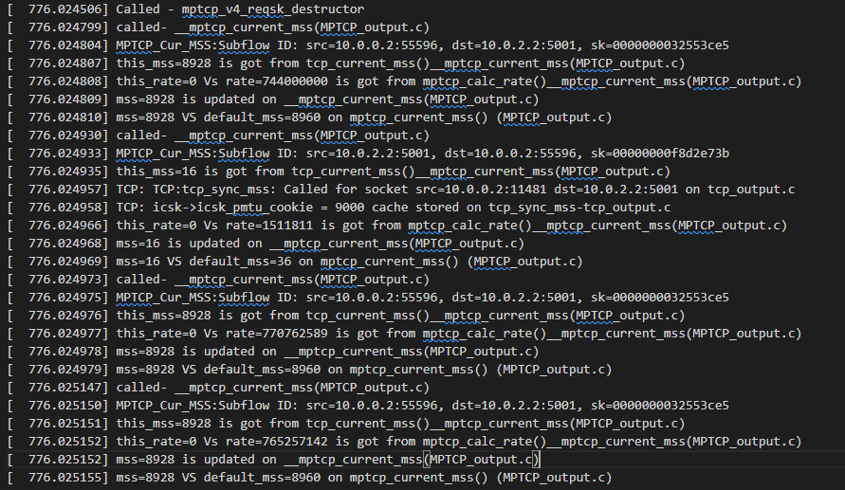

# Day 17

tcp_ipv4.c/:tcp_v4_init_sock()

tcp_output.c /:TCP: tcp_mtup_init() icsk_mtup.search_low = 1076 & mtup.search_high=576

1. TCP_output.c/:tcp_connect_init() [Local IP: 10.0.0.2, Remote IP: 10.0.2.2]
2. MPTCP_CTRL.C/:mptcp_connect_init()
3. MPTCP_CTRL.C/: mptcp_add_sock()
4. tcp_output.c /:TCP: tcp_mtup_init() [src=10.0.0.2:15550 dst=10.0.2.2]

icsk_mtup.search_low = 1076 & mtup.search_high=9000

1. MPTCP_CTRL.C/: mptcp_add_sock() Error: Unable to get destination info for 10.0.0.2
2. tcp_output.c /:TCP: tcp_mtup_init()

icsk_mtup.search_low = 1096 & mtup.search_high=9000

1. MPTCP_CTRL.C:mptcp_set_state() local_addr: 10.0.0.2

Now Path MTU is 9000 selected as this. ☹ Read by mptcp_set_state()

1. MPTCP_CTRL.C/: mptcp_add_sock()
2. tcp_output.c /:TCP: tcp_mtup_init() [src=10.0.2.2:35091 dst=10.0.0.2] Reverse
3. MPTCP_CTRL.C/: mptcp_add_sock() Error: Unable to get destination info for 10.0.2.2
4. MPTCP_CTRL.C:mptcp_set_state() local_addr: 10.0.2.2

Now Path MTU is 9000 selected as this. ☹ Read by mptcp_set_state()

mptcp_v4_reqsk_destructor

mptcp_init4_subsockets()- mptcp_ipv4.c

TCP: tcp_ipv4.c:tcp_v4_init_sock() called

__mptcp_init4_subsockets:MTU probing not enabled globally,skipping for subflow: 00000000bc2446e9

Adding new subflow

1. MPTCP_CTRL.C/: mptcp_add_sock()
2. tcp_output.c /:TCP: tcp_mtup_init() [src=0.0.0.0:0 dst=0.0.0.0:0]

icsk_mtup.search_low = 1044 & mtup.search_high=40

1. MPTCP_CTRL.C/: mptcp_add_sock() Error: Unable to get destination info for 0.0.0.0
2. __mptcp_init4_subsockets: path_index: 2 src_addr: 10.0.1.2:0 dst_addr: 10.0.2.2:5001
3. tcp_output.c /:TCP: tcp_mtup_init() [src=10.0.1.2:42976 dst=10.0.2.2:5001]

icsk_mtup.search_low = 1076 & mtup.search_high=576

1. TCP_output.c/:tcp_connect_init() [Local IP: 10.0.1.2, Remote IP: 10.0.2.2]
2. mptcp_v4_do_rcv() on mptcp_ipv4.c [src: 10.0.1.2, IP dest: 10.0.2.2]
3. mptcp_v4_join_request
4. mptcp_v4_join_init_req
5. __mptcp_init4_subsockets:Subflow PMTUD: Path MTU is 9000.

Now Path MTU is 9000 selected as this. ☹

1. tcp_output.c /:TCP: tcp_mtup_init() [src=10.0.1.2 dst=10.0.2.2]

icsk_mtup.search_low = 1096 & mtup.search_high=9000

1. MPTCP_CTRL.C:mptcp_set_state() local_addr: 10.0.1.2

Now Path MTU is 9000 selected as this. ☹ Read by mptcp_set_state()

1. MPTCP_CTRL.C/: mptcp_add_sock()
2. tcp_output.c /:TCP: tcp_mtup_init() [src=10.0.2.2: 35091 dst=10.0.1.2: 57511] Reverse

icsk_mtup.search_low = 1096 & mtup.search_high=9000

1. MPTCP_CTRL.C/: mptcp_add_sock() Synchronizing MSS with destination [src_addr:10.0.2.2:5001 dst_addr:10.0.1.2]
2. mptcp_v4_reqsk_destructor

# Day 18

In normal tcp

Tcp_tpv4.c/tcp_v4_err()

tcp_v4_err()

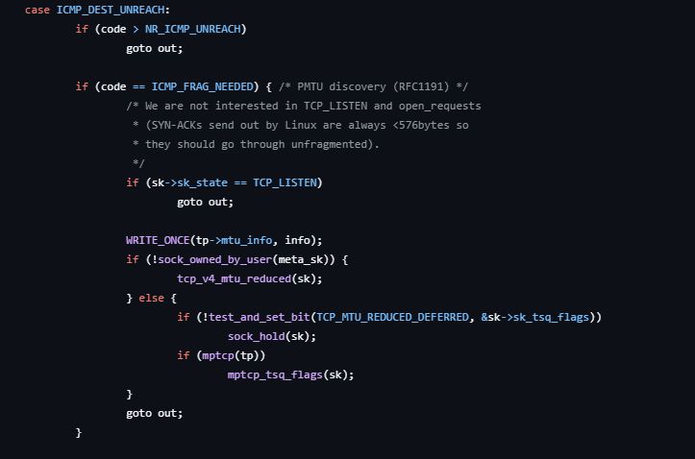

If the socket (meta_sk) is not currently "owned" by a user process:

tcp_v4_mtu_reduced(sk) handles the MTU reduction.

If the socket **is owned by a user process**:

Then the function defers the MTU adjustment:

* 1. It sets the TCP_MTU_REDUCED_DEFERRED flag to indicate the MTU reduction is pending.
  2. It calls sock_hold(sk) to prevent the socket from being released before the adjustment is made.

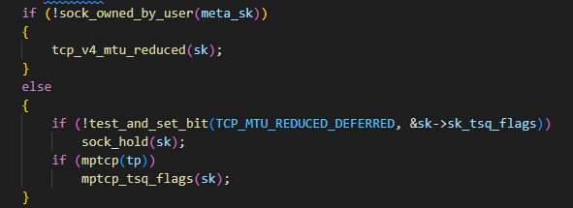

In mptcp.h file

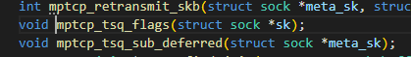

In tcp.h file

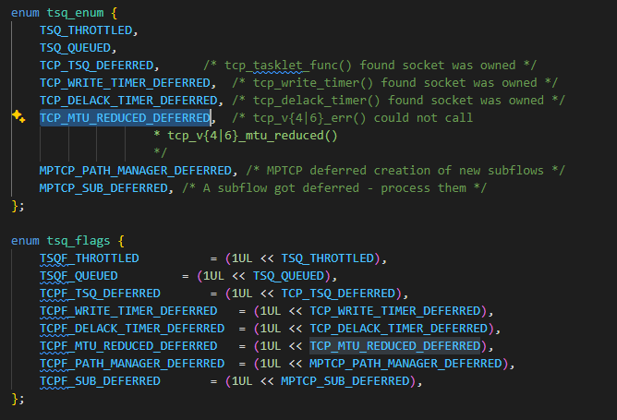

# Day 19

Called tcp_v4_mtu_reduced(sk) under MPTCP

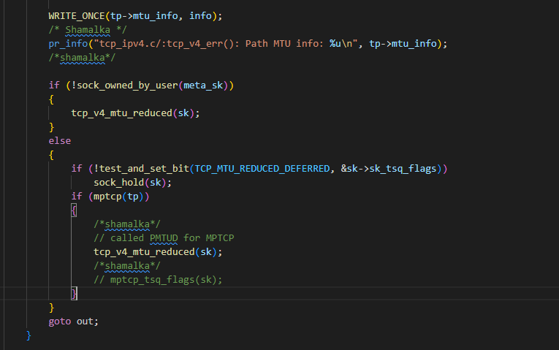

It didn’t work. Even that function is not called. Bcz this is tcp_v4_err() in tcp_ipv4.c.

I think mptcp uses mptcp_ip4.c file instead of this.

-------------------------------------------------------------------------

Day 20

Called need func 😊 when run mptcp and after doing ping, but without ping, intended func wasn’t called.

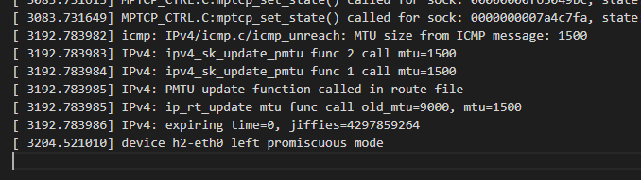

Net/ipv4/icmp.c/icmp_err() -> ipv4_update_pmtu()

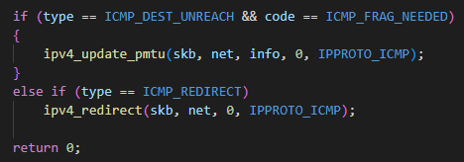

Ipv4/route.c/ipv4_update_pmtu() -> Ipv4/route.c/__ip_rt_update_pmtu()

ipv4_sk_update_pmtu() -> __ipv4_sk_update_pmtu()

ipv4_sk_update_pmtu() -> __ip_rt_update_pmtu()

Also ip_rt_update_pmtu() -> __ip_rt_update_pmtu()

But 2nd subflow mtu read as 552, which is minimum hardcoded one in source code.

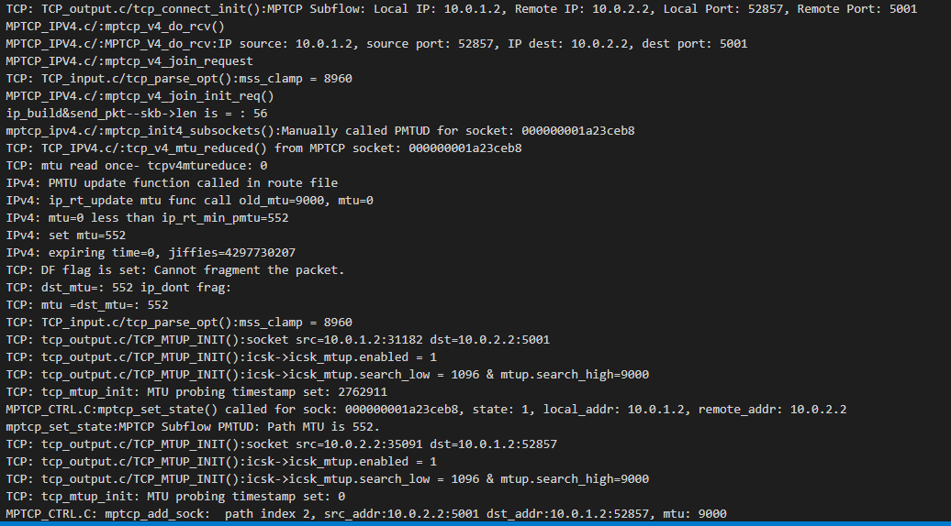

Day 21

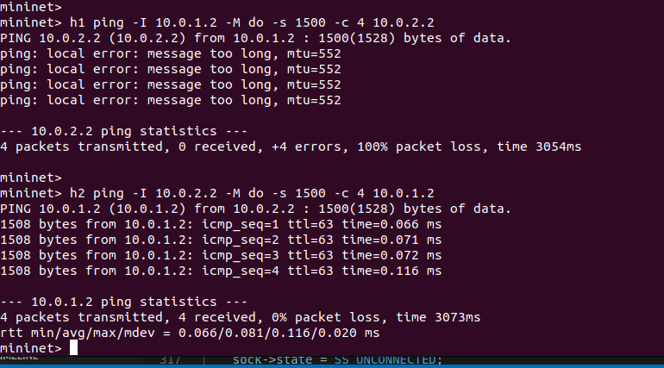

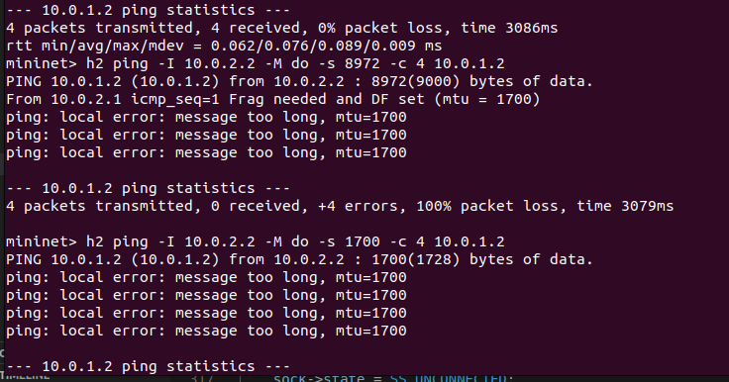

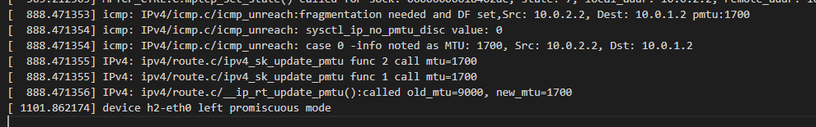

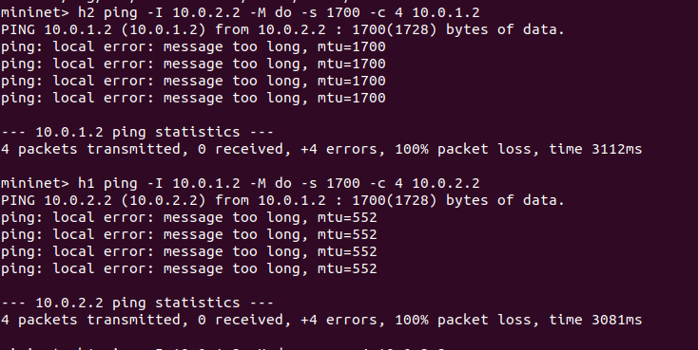

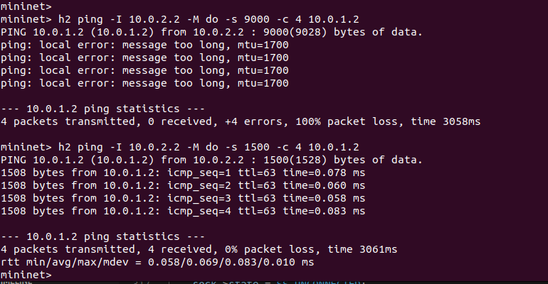

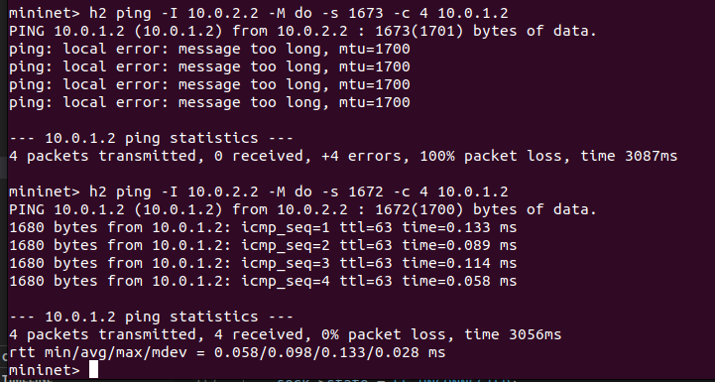

2nd test

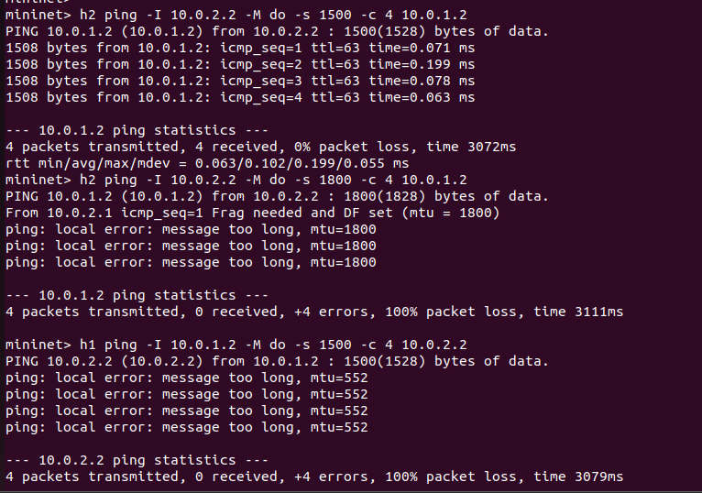

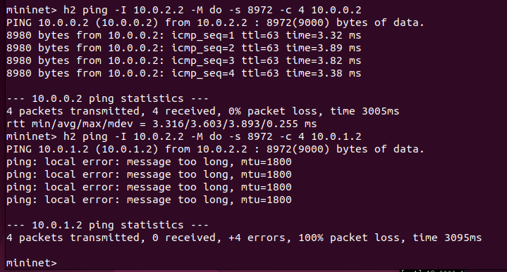

• **Unnecessary PMTUD Invocation**:

* PMTUD is typically triggered in response to ICMP messages (e.g., "Fragmentation Needed"). Manually calling tcp_v4_mtu_reduced() without actual feedback may:
  + Reduce the subflow's MTU unnecessarily.
  + Introduce performance degradation if packets are sent with a smaller-than-required MTU.

• **Redundant Logic**:

* PMTUD is already handled by the TCP layer when it receives ICMP messages. Manually invoking it in mptcp_set_state() duplicates functionality.

• **State Transition Timing**:

* mptcp_set_state() is called during state transitions. Triggering PMTUD here could lead to unexpected behavior, especially if the MTU adjustment isn't warranted.